The enthroned Christ and Emperor Leo VI the Wise
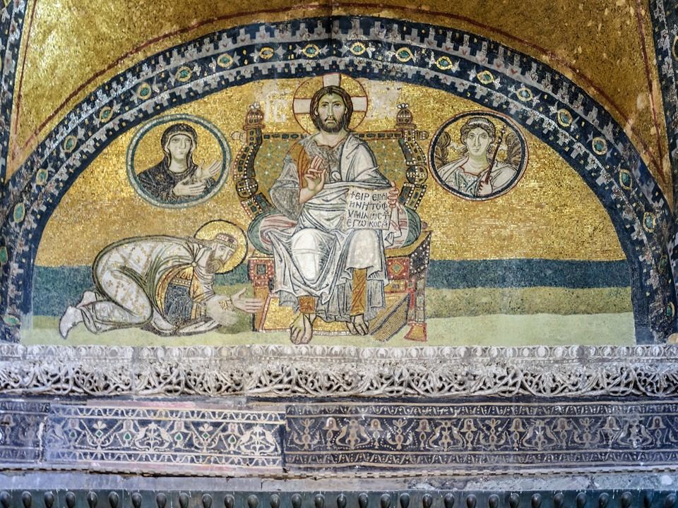
The Enthroned Christ and Emperor Leo VI the Wise, around the year 920, mosaic decorating the lunette over the Imperial Door of Hagia Sophia, the Great Church of Byzantium, Istanbul, Turkey https://www.pallasweb.com/deesis/inner-outer-narthex-hagia-sophia.html

The central figure is Christ, seated on a lyre-backed throne; his right hand is raised in front of him in blessing; resting on his left knee and supported by his left hand is an open book with the inscription Ειρήνη υμίν. Εγώ ειμί το φως του κόσμου (Peace to you; I am the Light of the world). To his right is a bearded emperor wearing ceremonial garments and a crown, who, in a prostrate position, raises his hands in supplication toward Christ… file:///C:/Users/aspil/OneDrive/Blog/Byzantium%20Mosaics/Leo%20the%20Wise%20Oikonomides.pdf

Student Activity
- Techer and students discuss the role the Imperial Gate served in the Great Church of Hagia Sophia during the Byzantine Period.
- Teacher and students observe and describe the composition of the famous Hagia Sophia mosaic of The Enthroned Christ and Emperor Leo VI the Wise on the lunette over the Imperial Door of Hagia Sophia.
- Students are asked to describe the purpose of the Mosaic located over the Imperial Gate of the Hagia Sophia

