Babylon Procession Way Lions
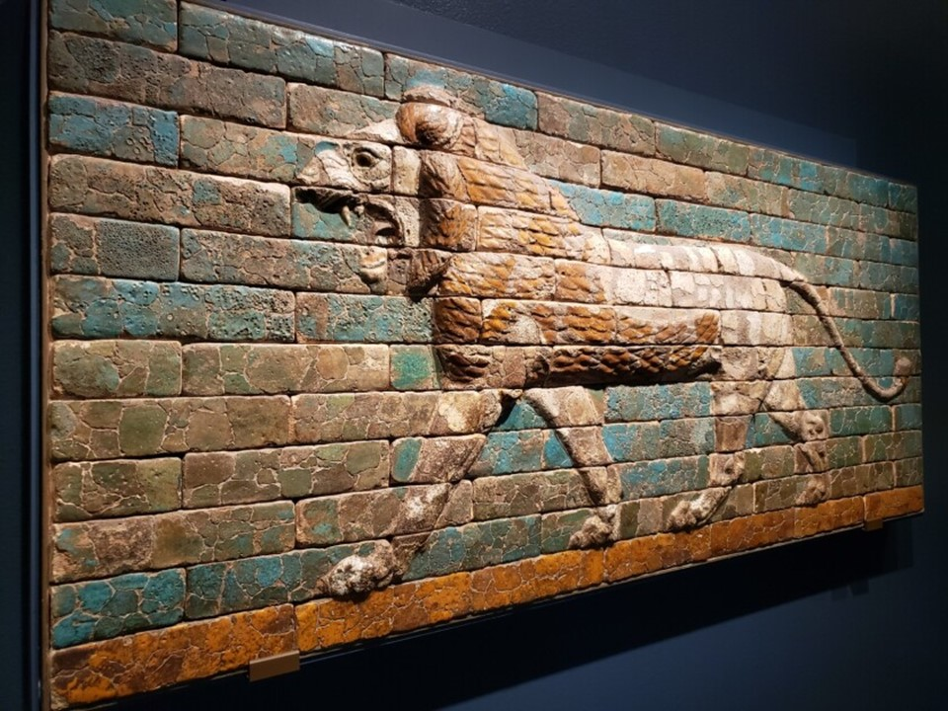

Panel with a Striding Lion, Neo-Babylonian period, 605–562 BC, glazed ceramic, 97.2 × 227.3 cm, the MET, NY, USA
https://www.latimes.com/entertainment-arts/story/2021-04-21/getty-villa-mesopotamia-louvre
The most important street in Babylon was the Processional Way, leading from the inner city through the Ishtar Gate to the Bit Akitu, or "House of the New Year's Festival. They were both built by Nebuchadnezzar II, and they were constructed with coloured glazed bricks, decorated with figures of Bulls and Dragons, symbols of the weather god Adad and of Marduk. North of the gate the Processional Way was lined with glazed figures of Striding Lions. The depicted lions, the animal associated with Ishtar, goddess of love and war, served to protect the street; their repeated design served as a guide for the ritual processions from the city to the temple. https://www.metmuseum.org/art/collection/search/322585  The Babylon Processional Way is a marvellous achievement of the reign of Nebuchadnezzar II. Monumental in size, colourful and highly ornate, the Processional Way was meant to dazzle the passer-by, citizen of the city of Babylon or traveller from afar. The entire structure served as a monument rather than having practical uses, and the religious devotion is clear cut in the representation of the gods in their animal form.  https://history2701.fandom.com/wiki/Processional_Way  Students are asked to study the Metropolitan Museum Panel with a Striding Lion.  They are also asked to study the easy way of Drawing a Lion in 6 Steps.  Finally, within the provided “shape” create their own Babylonian Striding Lion! https://gr.pinterest.com/pin/177821885264302756/ | 