The Fall of Icarus,
a Painting and a Poem
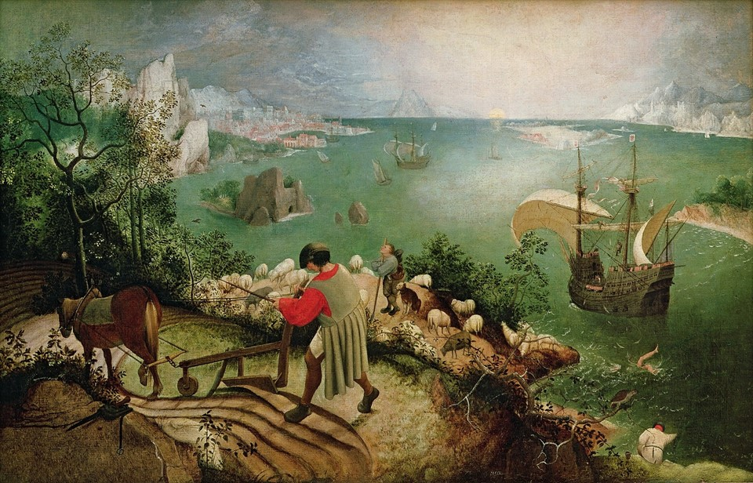
Pieter Brueghel the Elder (by/attributed), 1526/1530–1569
Landscape with the Fall of Icarus, circa 1558, oil on canvas mounted on wood, 73.5x112 cm, Royal Museums of Fine Arts of Belgium https://commons.wikimedia.org/wiki/File:Pieter_Bruegel_de_Oude_-_De_val_van_Icarus.jpg
Student Activity
- Look closely at the painting by or attributed to Pieter Brueghel the Elder titled Landscape with the Fall of Icarus
- Read the poem Lines on Brueghel’s “Icarus” by Michael Peter Leopold Hamburger
- Students are asked to participate in a class discussion and respond to the following questions.
- What’s going on in this painting?
- What do you see that makes you say that?
- What more can you find?
- Finally, students are asked to respond in writing to the following question: Why does this work stand out to you? What do you find interesting or moving about it?
Lines on Brueghel’s “Icarus” by Michael Peter Leopold Hamburger

The ploughman ploughs, the fisherman dreams of fish;
Aloft, the sailor, through a world of ropes
Guides tangled meditations, feverish
With memories of girls forsaken, hopes
Of brief reunions, new discoveries,
Past rum consumed, rum promised, rum potential.
Sheep crop the grass, lift up their heads and gaze
Into a sheepish present: the essential,
Illimitable juiciness of things,
Greens, yellows, browns are what they see.
Churlish and slow, the shepherd, hearing wings —
Perhaps an eagle’s–gapes uncertainly;

Too late. The worst has happened: lost to man,
The angel, Icarus, for ever failed,
Fallen with melted wings when, near the sun
He scorned the ordering planet, which prevailed
And, jeering, now slinks off, to rise once more.
But he–his damaged purpose drags him down —
Too far from his half-brothers on the shore,
Hardly conceivable, is left to drown.

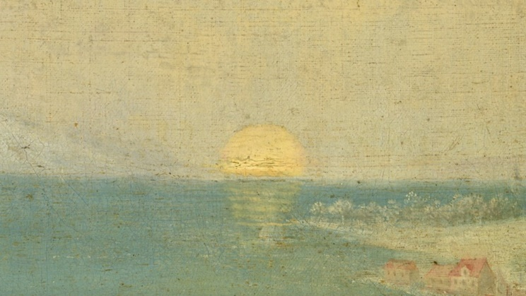
Landscape with the Fall of Icarus (detail of the sun), circa 1558, oil on canvas mounted on wood, 73.5x112 cm, Royal Museums of Fine Arts of Belgium https://www.dailyartmagazine.com/painting-of-the-week-pieter-bruegel-the-elder-landscape-with-the-fall-of-icarus/

