Imitating Edgar Degas Ballet Dancers
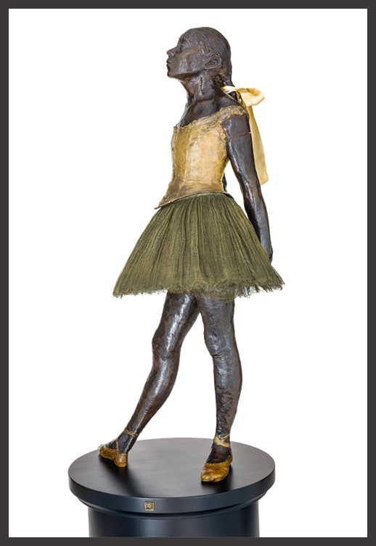
Edgar Degas, French Artist, 1834 - 1917
Little Dancer Aged Fourteen, circa 1878-1881, Bronze with brown patina, tulle skirt and satin ribbon on wooden base, Cast by A. A. Hébrard, Paris, circa 1922, 96.5×47×35 cm, Basil and Elise Goulandris Foundation, Athens, Greece
https://goulandris.gr/en/collection/highlights

This is an Inter-Disciplinary Art Appreciation Activity. The original idea came from the Instagram account Tussen Kunst & Quarantaine, where you can find dozens of such Art Recreations. My recommendation is to collaborate with the School’s Department of Performing Arts or Physical Education, use Edgar Degas Paintings or Statues of Ballet Dancers for inspiration and… Voila!

Instructions on what to do:

Research:

Find your favorite artwork by Edgar Degas. It can be a painting, or a statue!

How to research for Artworks on Ariadne: Go to Google – Edgar Degas Ballet Dancers - Pictures.
Recreate: Go the School’s Gym or Dance Studio. Every student comes prepared with the necessary props to recreate her/his favourite Degas artwork. When done… photograph each student.
Useful Tips:
1. Strike the correct Body Pose and take the right Facial Expression.
2. Pay attention to details like clothing, light, and texture

