The Etruscan Bronze Chandelier of Cortona
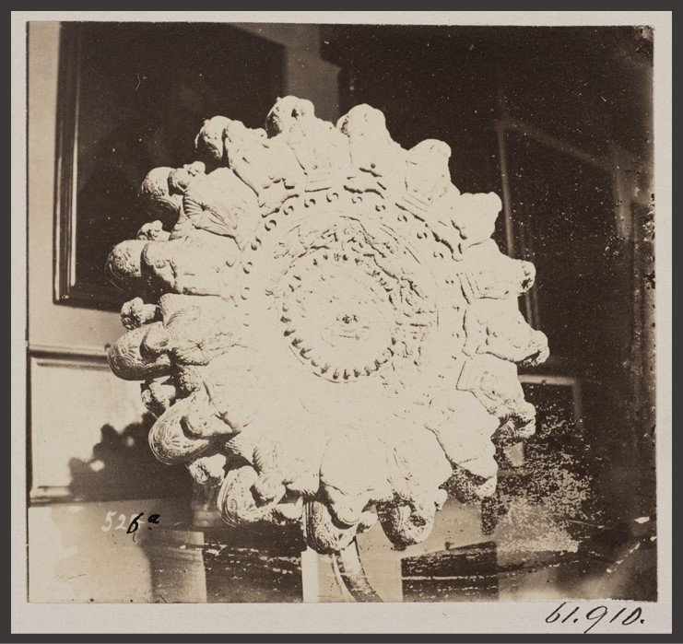
Commissioned by John Henry Parker (archaeologist - publisher), 1806-1884
Photograph of an Etruscan bronze lamp in the Cortona Museum, 1864-1868, photograph - mounted albumen print, 26.8x33.2cm, Victoria and Albert Museum, London, UK
https://collections.vam.ac.uk/item/O1098239/out-of-rome-cortona-photograph-parker-john-henry/out-of-rome-cortona--photograph-parker-john-henry/

According to the V&A Museum experts… This object is part of a series of over 3,300 photographs documenting the principal monuments, artworks and artefacts of Rome from the classical age to the 1600s. The photographs were taken between 1864 and 1879 under the direction of John Henry Parker (British Archaeologist), the founder of the British and American Archaeological Society of Rome, and many were published in his Archaeology of Rome (1874-1879). Parker employed local photographers including Adriano De Bonis, Filippo Spina, Carlo Baldassare Simelli, Francesco Sidoli, Filippo Lais and Giovanni Battista Colamedici, as well as a Canadian, Charles Smeaton. The Victoria and Albert Museum holds a large collection of the photographs taken before 1870. https://collections.vam.ac.uk/item/O1098239/out-of-rome-cortona-photograph-parker-john-henry/out-of-rome-cortona--photograph-parker-john-henry/

Discuss with students the role of Photography and Archaeology. Brainstorm the reasons why Archaeologist John Henry Parker commissioned so many photographs…

………………………………………………………………………………………………

………………………………………………………………………………………………

Do you think it is worth saving these old photographs and why?

………………………………………………………………………………………………

………………………………………………………………………………………………

According to the American School of Classical Studies at Athens experts… Photography is an excellent medium to record and illustrate quickly and objectively the archaeological record. Archaeological photography can be broadly divided into two categories: record photography of the actual excavations and object photography… https://www.ascsa.edu.gr/excavations/athenian-agora/stoa-of-attalos-research-center/photography-and-archives

Is this a record photography of the actual excavations and object photography?

………………………………………………………………………………………………

Archaeology developed as a specialist discipline with its own methodology and aims during the last quarter of the 19th century, and it is commonly accepted that improvements in archeological investigations were made through the application of advanced techniques, that were largely borrowed from natural sciences and applied in excavations. These helped field archaeologists to improve methods of recording, extract vital information from soil sequences, determine relationships between sites and draw inferences on the nature of the excavated ‘cultures’… https://www.researchgate.net/publication/242405361_The_camera_and_the_spade_Photography_in_the_making_archaeological_knowledge

Excavation photography helped archaeologists improve methods of …………………

………………………………………………………………………………………………

