Identify the Characteristics of a Tapestry

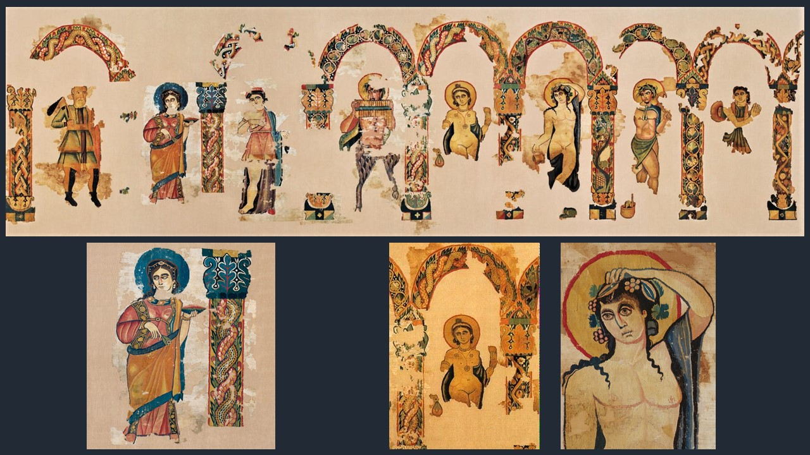
Dionysus and his entourage standing beneath arcades lavishly decked out with foliage and braided ornaments, from Egypt, 4th century AD, wool tapestry on linen ground, H. 210cm, W. ca. 700 cm, Abegg-Stiftung, Canton Bern , Switzerland https://twitter.com/Pythika/status/1141411261286146048/photo/1, https://abegg-stiftung.ch/en/ and https://twitter.com/caitlinrgreen/status/616963854870970368?lang=el

Discuss with students the art of Tapestry making

Students are asked to read… https://www.metmuseum.org/blogs/now-at-the-met/2014/making-a-tapestry and answer the following Questions:

What is, by definition, a Tapestry? ...………………………………………………………

………………………………………………………………………………………………

………………………………………………………………………………………………

Please explain what warps, and wefts are: …………………………………………………

………………………………………………………………………………………………

………………………………………………………………………………………………

Are coloured threads used for warps of wefts? …………………………………………….

What is a Tapestry “cartoon”? ……………………………………………………………..

………………………………………………………………………………………………

………………………………………………………………………………………………

Students are asked to “study” the Late Antique Abegg-Stiftung Tapestry of Dionyssos and identify the god of wine and theater and explain their reasons.

………………………………………………………………………………………………

………………………………………………………………………………………………

………………………………………………………………………………………………

Can students identify another ancient Greek God depicted in the Abegg-Stiftung Tapestry? Who is he? Which English word is a derivative of his name?

………………………………………………………………………………………………

………………………………………………………………………………………………

………………………………………………………………………………………………

