Claude Monet and the Rouen Cathedral Photo Credits

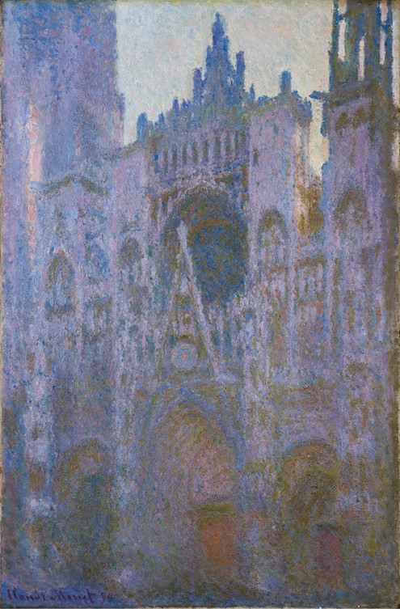

Rouen Cathedral in the Morning, Pink Dominant, 1894, Oil on canvas, 100.3 × 65.5 cm, Basil & Elise Goulandris Foundation, Athens https://upload.wikimedia.org/wikipedia/commons/2/20/Claude_Monet_-_La_Cathedrale_de_Rouen_Le_Matin%2C_dominante_rose_-_Goulandris_Museum.jpg

Slide 1 – Title – Claude Monet and the Rouen Cathedral
Slide 2
The Façade of the Rouen Cathedral
https://aknextphase.com/tag/notre-dame-cathedral-rouen/
Slide 3
Rouen Cathedral - The Portal seen from the front, 1892, oil on canvas, 107.0x74.0 cm, Orsay Museum, Paris, France https://www.musee-orsay.fr/en/collections/index-of-works/notice.html?no_cache=1&zoom=1&tx_damzoom_pi1%5Bzoom%5D=0&tx_damzoom_pi1%5BxmlId%5D=001286&tx_damzoom_pi1%5Bback%5D=%2Fen%2Fcollections%2Findex-of-works%2Fnotice.html%3Fnnumid%3D1286
Slide 4
Rouen Cathedral - The Portal, gray weather, 1892, oil on canvas, 100.2x65.4 cm, Orsay Museum, Paris, France https://www.musee-orsay.fr/en/collections/index-of-works/resultat-collection.html?no_cache=1&zoom=1&tx_damzoom_pi1%5Bzoom%5D=0&tx_damzoom_pi1%5BxmlId%5D=001288&tx_damzoom_pi1%5Bback%5D=en%2Fcollections%2Findex-of-works%2Fresultat-collection.html%3Fno_cache%3D1%26zsz%3D9
Slide 5
Rouen Cathedral study, 1892, Oil on canvas, 92.2x73.3 cm, Private Collection https://commons.wikimedia.org/wiki/File:Claude_Monet_-_Cathedrale_de_Rouen_-_Sothebys_7_may_2014.jpg
Slide 6
Rouen Cathedral – Effect of the Sun, end of the day, 1892, oil on canvas, 100x65 cm, Musée Marmottan Monet, Paris, France https://commons.wikimedia.org/wiki/File:Claude_Monet_-_Rouen_Cathedral,_Facade_(Sunset).JPG
Slide 7
Rouen Cathedral – Façade, 1892, oil on canvas, 100.4x65.4 cm, Pola Museum of Art, Japan
Slide 8
Rouen Cathedral – The Portal, morning sun, 1893, oil on canvas, 92.2x63.0 cm., Orsay Museum, Paris, France https://www.musee-orsay.fr/en/collections/index-of-works/resultat-collection.html?no_cache=1&zoom=1&tx_damzoom_pi1%5Bzoom%5D=0&tx_damzoom_pi1%5BxmlId%5D=001287&tx_damzoom_pi1%5Bback%5D=en%2Fcollections%2Findex-of-works%2Fresultat-collection.html%3Fno_cache%25
Slide 9
Rouen Cathedral - The Portal and the Saint-Romain Tower, morning effect, 1893, oil on canvas, 107.0x73.5 cm, Orsay Museum, Paris, France https://www.musee-orsay.fr/en/collections/index-of-works/resultat-collection.html?no_cache=1&zoom=1&tx_damzoom_pi1%5Bzoom%5D=0&tx_damzoom_pi1%5BxmlId%5D=001289&tx_damzoom_pi1%5Bback%5D=en%2Fcollections%2Findex-of-works%2Fresultat-collection.html%3Fno_cache%3D1%26zsz%3D9
Slide 10
Rouen Cathedral - The Portal and the Saint-Romain Tower, full sun, 1893, oil on canvas, 107.0x73.5 cm, Orsay Museum, Paris, France https://commons.wikimedia.org/wiki/File:%27The_Rouen_Cathedral_at_Sunset%27_by_Claude_Monet,_1894,_Pushkin_Museum.JPG
Slide 11
The Portal of Rouen Cathedral in Morning Light, 1894, oil on canvas, 100.3 × 65.1 cm, Getty Center, CA, USA https://www.getty.edu/art/collection/objects/131471/claude-monet-the-portal-of-rouen-cathedral-in-morning-light-french-1894/
Slide 12

Rouen Cathedral in the Morning, Pink Dominant, 1894, Oil on canvas, 100.3 × 65.5 cm, Basil & Elise Goulandris Foundation, Athens https://upload.wikimedia.org/wikipedia/commons/2/20/Claude_Monet_-_La_Cathedrale_de_Rouen_Le_Matin%2C_dominante_rose_-_Goulandris_Museum.jpg
Slide 13
Rouen Cathedral - Façade and Tour d'Albane, Morning Effect, 1894, oil on canvas, 106.1 x 73.9 cm, MFA, Boston, USA https://collections.mfa.org/objects/32103/rouen-cathedral-facade-and-tour-dalbane-morning-effect;jsessionid=3E861D8257BB10F15EBBEA92996561A7?ctx=edd8172c-8025-444a-8a89-d1eb0645c5ac&idx=1
Slide 14
Rouen Cathedral - The Portal, Sunlight, 1894, oil on canvas, 99.7 x 65.7 cm, the MET, NY, USA https://upload.wikimedia.org/wikipedia/commons/3/39/Claude_Monet_-_Rouen_Cathedral_-_The_Portal_%28Sunlight%29.jpg
Slide 15
Rouen Cathedral - The Façade in Sunlight, 1894, oil on canvas, 106.7 x 73.7 cm, the CLARK, MA, USA https://www.clarkart.edu/ArtPiece/Detail/Rouen-Cathedral,-the-Facade-in-Sunlight
Slide 16
Rouen Cathedral - West Façade, Sunlight, 1894, oil on canvas, 100.1 x 65.8 cm, NGA, Washington DC, USA https://www.nga.gov/collection/art-object-page.46654.html
Slide 17
Rouen Cathedral - The Façade, 1894, oil on canvas, 100 × 65 cm, National Museum of Serbia https://commons.wikimedia.org/wiki/File:Claude_Monet_-_Cathedrale_de_Rouen_-_Beograd_museum.jpg
Slide 18
Rouen Cathedral - The Façade, 1894, oil on canvas, 100.6 x 66.0 cm, MFA, Boston, USA https://collections.mfa.org/objects/32700/rouen-cathedral-facade;jsessionid=3E861D8257BB10F15EBBEA92996561A7?ctx=edd8172c-8025-444a-8a89-d1eb0645c5ac&idx=2
Slide 19
Rouen Cathedral - The Façade, 1894, oil on canvas, 100x65 cm, Schloss Weimar Collection, Germany https://commons.wikimedia.org/wiki/File:Claude_Monet_Kathedrale_von_Rouen@20151002_01.JPG
Slide 20
Rouen Cathedral – Façade, Sun Effects, Sunset, 1894, oil on canvas, 100.2x65.3 cm, Pushkin Museum, Moscow, Russia https://commons.wikimedia.org/wiki/Category:Rouen_Cathedral_by_Monet#/media/File:Claude_Monet_-_The_Rouen_Cathedral_at_Sunset_-_Pushkin_museum.jpg
Slide 21
Rouen Cathedral – Façade, Sunset, 1894, oil on canvas, 100x65 cm, Musée Marmottan Monet, Paris, France https://commons.wikimedia.org/wiki/File:Claude_Monet_-_Rouen_Cathedral,_Facade_(Sunset).JPG
Slide 22
Rouen Cathedral – The Portal and the Albane Tower, Symphony in Grey, 1894, oil on canvas, 102x74 cm, Musée des Beaux-Arts de Rouen, France https://mbarouen.fr/fr/oeuvres/la-cathedrale-de-rouen-le-portail-et-la-tour-d-albane-temps-gris
Slide 23
Rouen Cathedral – The Portal, Symphony in Grey and Pink, 1894, oil on canvas, 100x65 cm, National Museum Cardiff, UK https://commons.wikimedia.org/wiki/File:Rouen_Cathedral-_Setting_Sun,_Symphony_in_Grey_and_Pink.jpg
Slide 24
For Identifications and Photo Credits, please go to:
Slide 25
The End

