Antonello da Messina - Camera degli Sposi

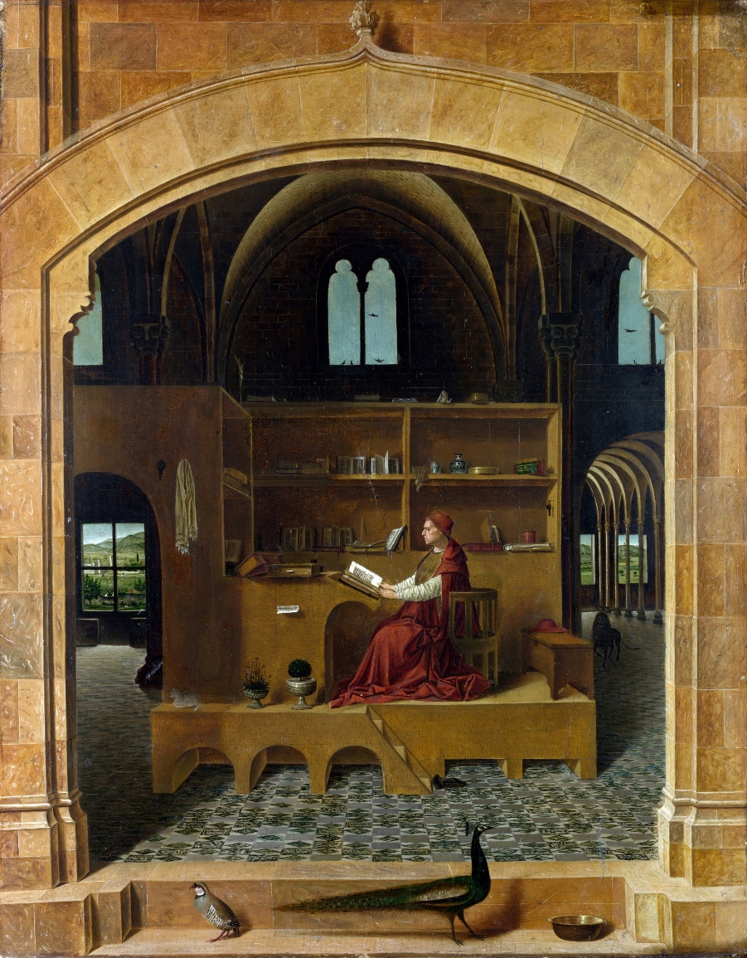

St Jerome in his Study, c. 1460, Oil on wood, 46 x 36 cm, National Gallery, London

Like Reading a wonderful book, students can “READ” a work of art. It’s a cognitive process students acquire by enhancing, with the help of their teachers, their observation skills , attention to pictorial details, an analysis of what they discover and finally the cultural connections they can draw.

Let’s help students Practice their skills and strengthen their abilities with the right questions…
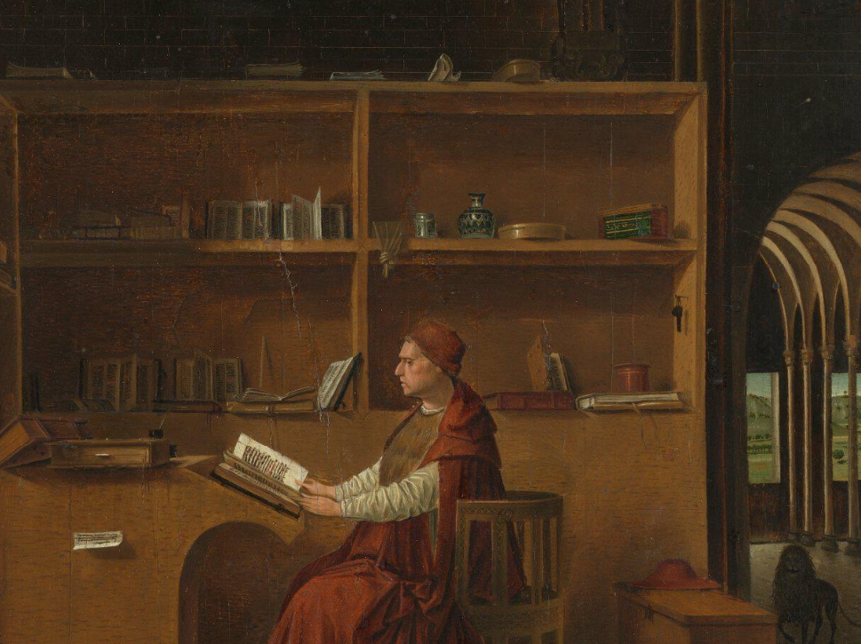

Take time to examine, carefully, Antonello da Messina’s fresco depicting St Jerome in his Study in the National Gallery in London… search for “obscure” details.

Explore the National Gallery Site Presentation: https://www.nationalgallery.org.uk/paintings/antonello-da-messina-saint-jerome-in-his-study
Read the In-depth Description
Watch Caroline Campbell, the National Gallery's Director of Collections and Research, discuss the Renaissance painter Antonello da Messina's painting, 'Saint Jerome in his Study'.

Answer the following:

I notice…
It seems…
The mood appears to be… because…
I find very interesting…
This painting makes me feel… because…
Virgin Annunciate and Poetry

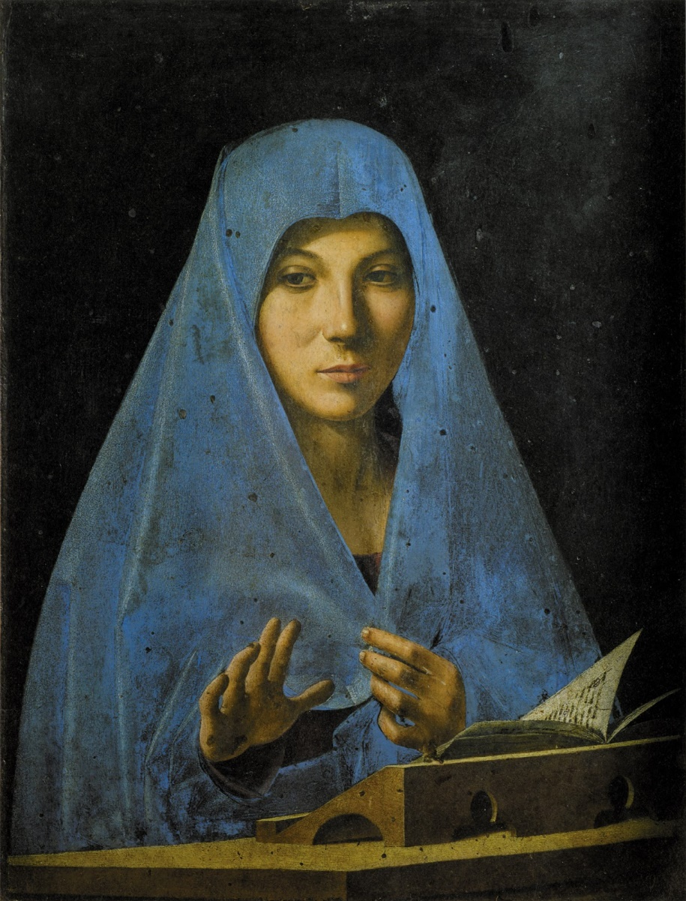

Virgin Annunciate, c. 1476, Oil on wood, 45 x 34,5 cm, Galleria Regionale della Sicilia, Palermo

Introduce students the Virgin Annunciate painting in the Galleria Regionale della Sicilia at Palermo: https://libmma.contentdm.oclc.org/digital/collection/p15324coll10/id/51380/rec/5 page 46
Students are then asked to create a Word Cloud describing the “mood” of Antonello’s painting.
Portrait of a Man

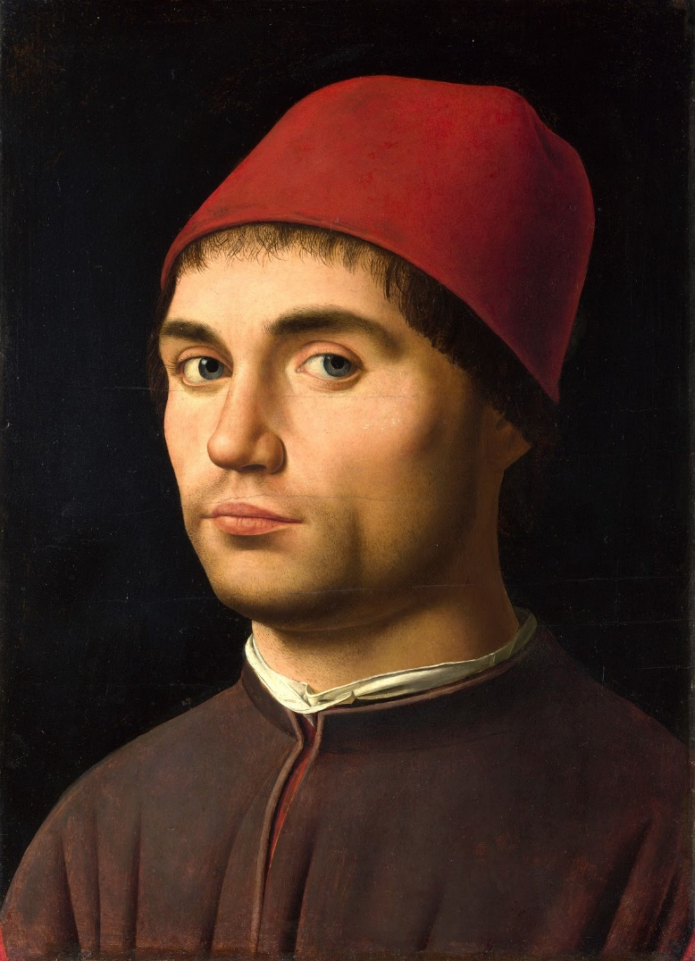

Portrait of a Man, c. 1475, Oil on panel, 36 x 25 cm, National Gallery, London

The National Gallery experts write about the Portrait of a Man… “This small painting shows how Antonello revolutionised Venetian portraiture in the late fifteenth century: the three-quarter pose, dark background and strong lighting are all innovations from Northern Europe which focus attention entirely on the man’s face…” https://www.nationalgallery.org.uk/paintings/antonello-da-messina-portrait-of-a-man
No scholar has yet determined the reasons for the commissioning of a Portrait or what its function may have been. Students are asked to draw up scripts to account for the purposes, Man in the Portrait had, in commissioning and displaying the painting.

