Andrea Mantegna - Camera degli Sposi

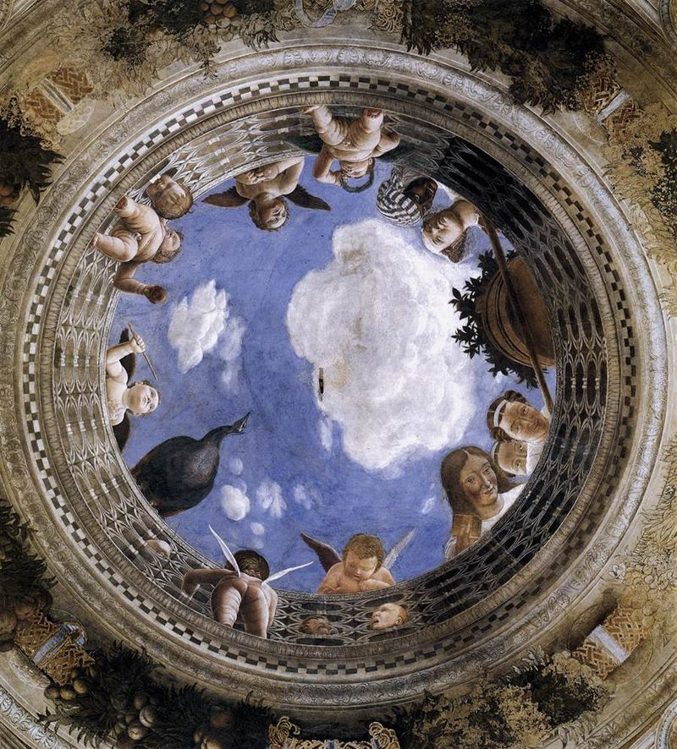

Ceiling decoration of the Camera degli Sposi, 1465-74, Walnut oil on plaster and fresco, Camera degli Sposi, Palazzo Ducale, Mantua

Explain to a friend (a leter or a postcard or a Video) why visiting Camera degli Sposi in the Palazzo Publico in Florence is crucial to understand the revolution occurred to the traditional Art schemes of Italian painting during the 15th century.
https://guideturistichemantova.it/camera-degli-sposi/
Andrea Mantegna – The Louvre Saint Sebastian

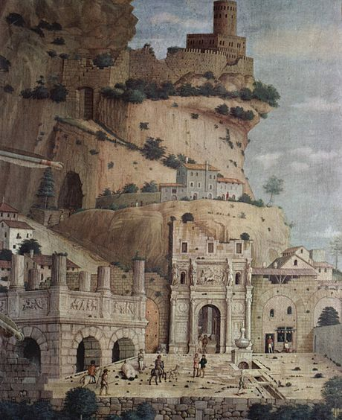

St Sebastian (detail), c. 1480, Tempera on canvas, 255 x 140 cm, Musée du Louvre, Paris

Students are asked to read: https://www.louvre.fr/en/oeuvre-notices/saint-sebastian
Students are then asked to discuss and finally answer the following question: Where and how does Andrea Mantegna show his fascination with ancient Greek and Roman Art?
Andrea Mantegna - Camera degli Sposi

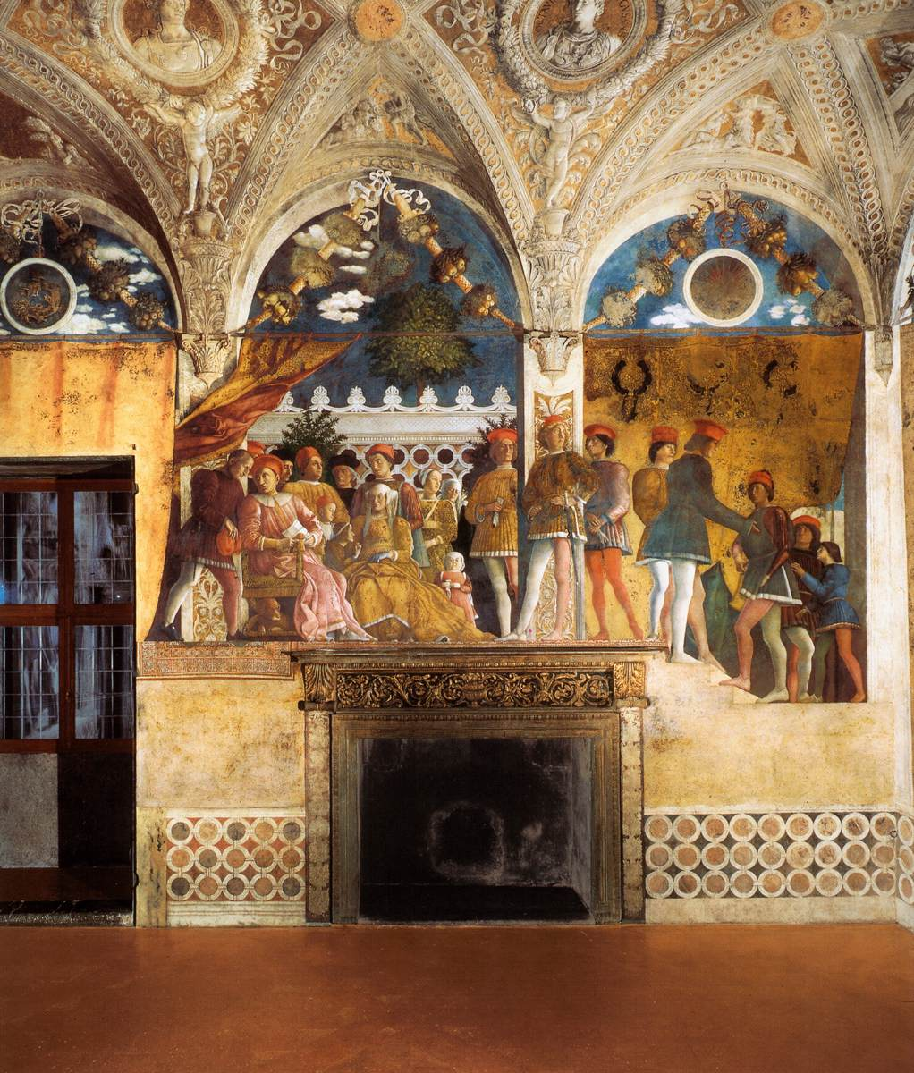

The Camera degli Sposi, The north wall: The Court of Gonzaga, 1465-74, Walnut oil on plaster, Camera degli Sposi, Palazzo Ducale, Mantua

Like Reading a wonderful book, students can “READ” a work of art. It’s a cognitive process students acquire by enhancing, with the help of their teachers, their observation skills , attention to pictorial details, an analysis of what they discover and finally the cultural connections they can draw.

Let’s help students Practice their skills and strengthen their abilities with the right questions…

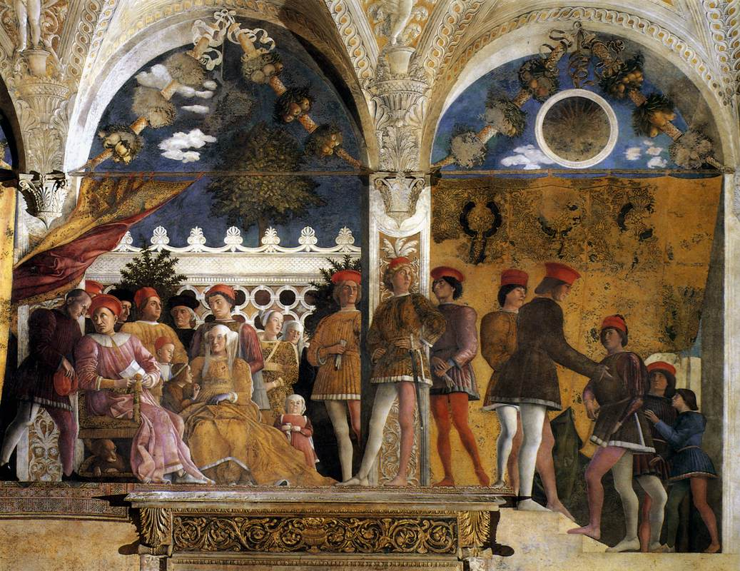

Take time to examine, carefully, Mantegn’a fresco depicting the The Court of Gonzaga in the Palazzo Ducale at Mantua… search for “obscure” details.
Watch: https://www.khanacademy.org/humanities/renaissance-reformation/early-renaissance1/venice-early-ren/v/andrea-mantegna-camera-degli-sposi-frescos-in-the-ducal-palace-mantua-1465-74
Read: http://www.travelingintuscany.com/art/andreamantegna/cameradeglisposi.htm
Answer the following:

I notice…
It seems…
The mood appears to be… because…
This is fresco is connected to the …. because…
I find very interesting…
This fresco makes me feel… because…
Andrea Mantegna – A Valentine’s Activity

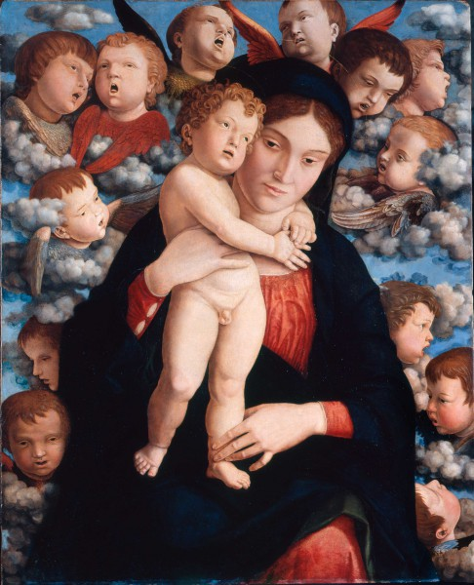

Madonna of the Cherubim , c. 1485, Panel, 88 x 70 cm, Pinacoteca di Brera, Milan

Introduce students the Madonna of the Cherubim in the Brera Pinacoteca at Milan: https://pinacotecabrera.org/en/collezione-online/opere/madonna-and-child-with-a-choir-of-cherubs/
Use
https://www.drawingnow.com/tutorials/113932/how-to-draw-a-cherub/ and https://www.youtube.com/watch?v=IgUtuIFOrt0
Assist students to draw their own Cherubim!
When students finish their drawing, they are asked to write a sentence explaining what a Cherubim is and then another sentence to dedicate their drawing to a loved one.
Andrea Mantegna – A Foreshortening Activity

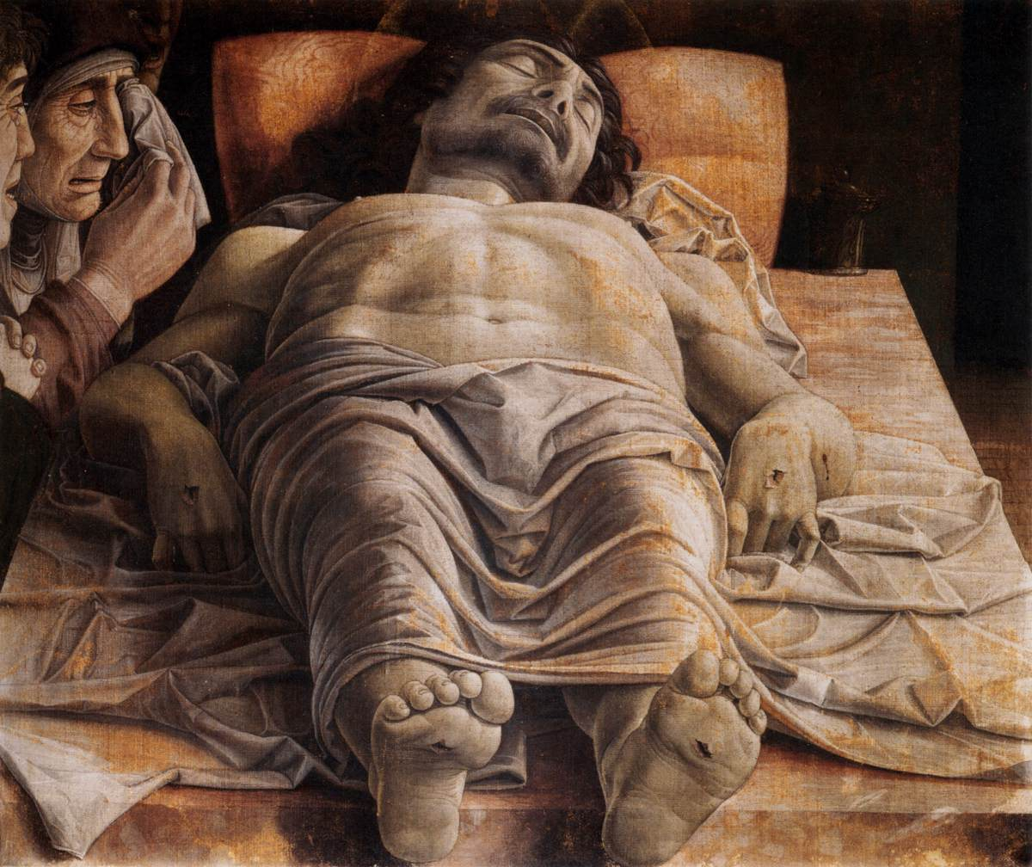

The Lamentation over the Dead Christ, c. 1490, Tempera on canvas, 68 x 81 cm, Pinacoteca di Brera, Milan

Introduce students the Lamentation over the Dead Christ in the Brera Pinacoteca at Milan: https://pinacotecabrera.org/en/collezione-online/opere/the-dead-christ-and-three-mourners/
Students are asked to find , and then share with class a Definition for what Foreshortening is in Art
Students are asked to Search for Andrea Mantegna’s paintings where foreshortening is practiced. Find three examples, correctly identify them, and present them to class.

