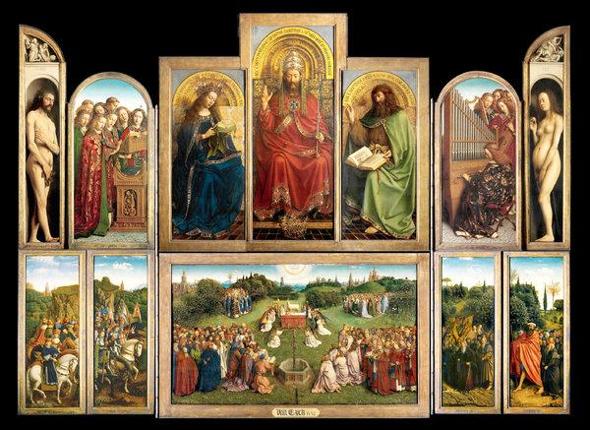
Jan van Eyck, b. before 1395 - d. 1441, Bruges
The Ghent Altarpiece (wings open), 1432, Oil on wood, 350 x 461 cm, Cathedral of St Bavo, Ghent

Jan van Eyck and the Ghent Altarpiece

“As the defining monument of the "new realism" of Northern Renaissance art, the Ghent Altarpiece was regarded as both the foundation of a distinguished tradition, and an exemplary achievement to challenge all later artists. In 1495, a visitor named Hieronymus Münzer justly described it as encompassing the whole art of painting.
The discovery in 1823 of a rhymed quatrain on the frame of the altarpiece confirmed that it was begun by Hubert van Eyck, described as greater than his brother Jan, who completed the work upon Hubert's death in 1426. No one has ever distinguished their respective shares in this painting. Dedicated on May 6, 1432 in the Church of Saint John, Ghent (now the Cathedral of Saint Bavo), the work was installed above an altar in a chapel founded by the wealthy patrician Joos Vijd and his wife Elizabeth Borluut.
The astonishing realism of the altarpiece rests not only in the fidelity with which figures, plants, and animals are represented in a convincing space, but also in its ability to forge a sense of continuity between the pictorial and the real world. On the exterior, the frames between the painted panels of the Annunciation scene appear to cast shadows into the Virgin's chamber, in accordance with the actual direction of light in the Vijd Chapel. On the lower level, the technique of grisaille is used to depict fictive statues of the two Saints John, possibly as a painterly challenge to the long-established convention of sculpted retables. More astonishing still are the near-life size nudes of Adam and Eve on the interior, who appear to project out of the depths of their niches into real space.
The complex theological program is based partly on the liturgy for All Saints' Day, which included readings from the Book of Revelation; however, no single text has been found to "explain" the entire program. Rather, the work stands on its own as a visual account of the redemptive mysteries of the Catholic faith, beginning with the incarnation of Christ at the moment of the Annunciation represented on the exterior. Didactic and identifying inscriptions, including legible texts in painted books, amplify and explain the imagery.
When the wings are open, the main feature of the lower level is a continuous heavenly landscape, verdant and rich, through which a multitude of figures travel on horseback and on foot to adore the mystic lamb of God on the central altar. The lamb, whose blood flows into a chalice, symbolizes the Eucharistic sacrifice of Christ celebrated through the daily masses in the Vijd Chapel. Underlining the concept of the Mass as the source of eternal grace is the stream of crystal-clear water gushing from the Fountain of Life in the center panel, which, with daring realism, is channeled downward toward the actual altar itself. At the upper level is a Deësis, showing Christ as High Priest, flanked by the Virgin Mary and John the Baptist, in the positions they assume as intercessors at the Last Judgment. To the left and right, angels play instruments and sing, their expressions reflecting their vocal pitch. Adam and Eve, at left and right, stand as the originators of sin in the world.
By the end of the 15th century, visitors were already paying to see this painting in the chapel; artists who admired it include the painter Gerard David, who made drawings from it and, in 1521, the German painter and printmaker Albrecht Dürer.”
https://www.metmuseum.org/toah/hd/ghnt/hd_ghnt.htm

Further reading: https://news.harvard.edu/gazette/story/2008/04/ghent-altarpiece-is-window-into-history-of-art/

Questions for students to Answer…

Students are asked to define Realism. Explain where they see Realism in the Ghent Altarpiece and give examples of their statements.

Students are sked to explain what grisaille is in painting. Where and why did van Eyck use the grisaille technique in the Ghent Altarpiece?

What do you like most in the Ghent Altarpiece? Why?

