Jan van Eyck, b. before 1395 - d. 1441
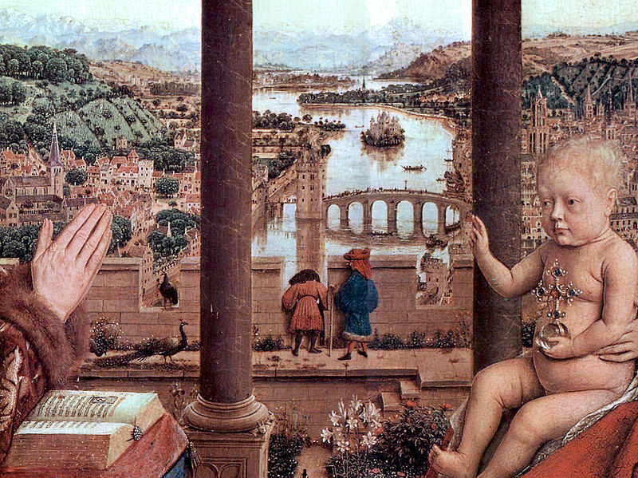
List of Slides and Photo Credits

Slide 1
Title of PowerPoint
Slide 2
Portrait of a Man (Self Portrait?), 1433, Oil on Oak, 26x19 cm, The National Gallery, London
https://commons.wikimedia.org/wiki/Category:Man_in_a_Turban_by_Jan_van_Eyck#/media/File:Portrait_of_a_Man_by_Jan_van_Eyck-small.jpg
Portrait of Margaret van Eyck , 1439, Oil on Panel, 41.2cm x 34.6cm. Groeningemuseum, Bruges
https://commons.wikimedia.org/wiki/File:Portrait_of_Margaret_van_Eyck.jpg
Slide 3
Portrait of a Man (Self Portrait?) (detail), 1433, Oil on Oak, 26x19 cm, The National Gallery, London
https://commons.wikimedia.org/wiki/Category:Man_in_a_Turban_by_Jan_van_Eyck#/media/File:Jan_van_eyck,_ritratto_d'uomo,_forse_autoritratto,_1433,_02_als_ich_kan.jpg
Portrait of Margaret van Eyck (detail) , 1439, Oil on Panel, 41.2cm x 34.6cm. Groeningemuseum, Bruges
https://www.nationalgallery.org.uk/research/research-papers/the-restoration-of-margaret-the-artists-wife/the-restoration-of-margaret-the-artists-wife
Slide 4
Portrait of a Man with a Blue Chaperon (and detail), c. 1428−1430, Oil on panel, 22 x 17 cm, Muzeul National Brukenthal, Sibiu (Romania)
https://en.wikipedia.org/wiki/Portrait_of_a_Man_with_a_Blue_Chaperon
https://www.pinterest.ca/pin/555631672762352220/
Slide 5
The Ghent Altarpiece or The Adoration of the Mystic Lamb Altarpiece, 1432, Oil on panel, Saint Bavo’s Cathedral, Ghent, Belgium
For a POWERPONT on the Ghent Altarpiece… PLEASE CHECK THE POST
https://commons.wikimedia.org/wiki/Category:Ghent_Altarpiece_by_Jan_van_Eyck#/media/File:Eyck.hubert.lamb.750pix.jpg
https://flandersfields1418.prezly.com/an-exceptional-loan-from-the-national-gallery-in-london-is-being-restored-for-next-years-van-eyck-exhibition-in-ghent-belgium
Slide 6
Saint Francis of Assisi Receiving the Stigmata, 1430-1432, Oil on vellum on panel, 12.7 × 14.6 cm, Philadelphia Museum of Art
https://en.wikipedia.org/wiki/File:Saint_Francis_of_Assisi_Receiving_the_Stigmata.jpg
Slide 7
Saint Francis of Assisi Receiving the Stigmata, 1430-1432, Oil on vellum on panel, 12.7 × 14.6 cm, Philadelphia Museum of Art
https://www.wikiwand.com/en/Saint_Francis_Receiving_the_Stigmata_(van_Eyck)
Slide 8
Portrait of a Man ('Léal Souvenir’) (and detail), 1432, Oil on Oak, 33.3 x 18.9 cm, National Gallery, London
https://www.nationalgallery.org.uk/paintings/jan-van-eyck-portrait-of-a-man-leal-souvenir
Slide 9
The Annunciation Diptych, c. 1433-1435, Oil on panel, Left: 38.8 x 23.2 cm, Right: 39 x 24 cm, Museo Nacional Thyssen-Bornemisza, Madrid
http://www2.museothyssen.org/microsites/Proyecto_VERONA/diptico_anunciacion.html
Slide 10
Portrait of Giovanni Arnolfini and his Wife (and details), 1434, Oil on oak, 82 x 60 cm, National Gallery, London
https://en.wikipedia.org/wiki/Arnolfini_Portrait#/media/File:Van_Eyck_-_Arnolfini_Portrait.jpg
https://en.wikipedia.org/wiki/Arnolfini_Portrait#/media/File:The_Arnolfini_Portrait,_d%C3%A9tail_(6).jpg
https://en.wikipedia.org/wiki/Arnolfini_Portrait#/media/File:Arnolfini_Portrait_3.jpg
Slide 11
Portrait of Giovanni Arnolfini and his Wife (detail), 1434, Oil on oak, 82 x 60 cm, National Gallery, London
https://www.artstor.org/2017/06/06/the-many-questions-surrounding-jan-van-eycks-arnolfini-portrait/
Slide 12
Portrait of Giovanni Arnolfini and his Wife (detail), 1434, Oil on oak, 82 x 60 cm, National Gallery, London
https://en.wikipedia.org/wiki/Arnolfini_Portrait#/media/File:The_Arnolfini_Portrait,_d%C3%A9tail_(2).jpg
Slide 13
Portrait of Giovanni Arnolfini and his Wife (details), 1434, Oil on oak, 82 x 60 cm, National Gallery, London
https://en.wikipedia.org/wiki/Arnolfini_Portrait#/media/File:Jan_van_Eyck_009.jpg
https://www.wga.hu/support/viewer/z.html
Slide 14
The Virgin of Chancellor Rolin (and detail), 1435, wood, 66 x 62 cm, Musée du Louvre, Paris
https://www.wga.hu/support/viewer/z.html
https://www.wga.hu/support/viewer/z.html
Slide 15
The Virgin of Chancellor Rolin (details), 1435, wood, 66 x 62 cm, Musée du Louvre, Paris
https://www.wga.hu/support/viewer/z.html
https://www.wga.hu/support/viewer/z.html
Slide 16
The Annunciation, c. 1435, Oil transferred from wood to canvas, 93 x 37 cm, National Gallery of Art, Washington DC
https://en.wikipedia.org/wiki/Annunciation_(van_Eyck,_Washington)#/media/File:Annunciation_-_Jan_van_Eyck_-_1434_-_NG_Wash_DC.jpg The Annunciation (detail), c. 1435, Oil transferred from wood to canvas, 93 x 37 cm, National Gallery of Art, Washington DC
https://en.wikipedia.org/wiki/Annunciation_(van_Eyck,_Washington)#/media/File:Annunciation_(van_Eyck,_Washington)_Mary.jpg
Slide 17
The Annunciation(details), c. 1435, Oil transferred from wood to canvas, 93 x 37 cm, National Gallery of Art, Washington DC (Floor tiles detail: David slaying Goliath in front, Samson pulling down the Philistines' Temple behind)
https://commons.wikimedia.org/wiki/File:Annunciation_-_Jan_van_Eyck_-_1434_-_bottom.jpg
https://en.wikipedia.org/wiki/Annunciation_(van_Eyck,_Washington)#/media/File:Jan_van_Eyck_081.jpg
Slide 18
Portrait of Baudouin de Lannoy, c. 1435, Oil on panel, 26.6x19.6cm, Gemäldegalerie der StaatlichenMuseen zu Berlin–PreussischerKulturbesitz, Berlin
http://closertovaneyck.kikirpa.be,©KIK-IRPA, Brussel
https://commons.wikimedia.org/wiki/File:Jan_van_eyck,_ritratto_di_baudouin_de_lannoy,_1436-38_ca._01.JPG
Detail of the sitter’s eye
https://www.smb.museum/en/museums-institutions/gemaeldegalerie/collection-research/conservation-care/jan-van-eycks-portrait-of-baudouin-de-lannoy.html
Slide 19
Portrait of Baudouin de Lannoy (detail), c. 1435, Oil on panel, 26.6x19.6cm, Gemäldegalerie der StaatlichenMuseen zu Berlin–PreussischerKulturbesitz, Berlin
https://www.smb.museum/en/museums-institutions/gemaeldegalerie/collection-research/conservation-care/jan-van-eycks-portrait-of-baudouin-de-lannoy.html
Slide 20
Portrait of Giovanni di Nicolao Arnolfini, 1435, 29 x 20 cm, Gemäldegalerie, Berlin
https://en.wikipedia.org/wiki/Portrait_of_Giovanni_di_Nicolao_Arnolfini#/media/File:Jan_van_Eyck_-_Portrait_of_Giovanni_Arnolfini_-_WGA7608.jpg
Slide 21
Saint Jerome in His Study (and details), ca. 1435, oil on linen paper on oak panel, Unframed: 20.6 × 13.3 cm, Detroit Institute of Arts
https://commons.wikimedia.org/wiki/File:Jan_van_Eyck_-_Saint_Jerome_in_His_Study_-_25.4_-_Detroit_Institute_of_Arts.jpg
https://commons.wikimedia.org/wiki/File:Jan_van_eyck,_san_girolamo_nello_studio,_1435_ca._02_libri.jpg
https://commons.wikimedia.org/wiki/File:Jan_van_eyck,_san_girolamo_nello_studio,_1435_ca._04_leone.jpg
Slide 22
The Madonna with Canon van der Paele, 1436, Oil on wood, 122 x 157 cm, Groeninge Museum, Bruges
https://en.wikipedia.org/wiki/Virgin_and_Child_with_Canon_van_der_Paele#/media/File:La_Madone_au_Chanoine_Van_der_Paele.jpg
Slide 23
The Madonna with Canon van der Paele (details), 1436, Oil on wood, 122 x 157 cm, Groeninge Museum, Bruges
https://en.wikipedia.org/wiki/Virgin_and_Child_with_Canon_van_der_Paele#/media/File:Canon_van_der_Paele_(_Donatian)_Van_Eyck.jpg
https://en.wikipedia.org/wiki/Virgin_and_Child_with_Canon_van_der_Paele#/media/File:Canon_van_der_Paele_Van_Eyck.jpg
Slide 24
The Madonna with Canon van der Paele (details), 1436, Oil on wood, 122 x 157 cm, Groeninge Museum, Bruges
http://vlaamseprimitieven.vlaamsekunstcollectie.be/en/research/webpublications/madonna-with-canon-joris-van-der-paele
https://en.wikipedia.org/wiki/Virgin_and_Child_with_Canon_van_der_Paele
Slide 25
Portrait of Jan de Leeuw, 1436, Oil on panel, 33 x 27,5 cm, Kunsthistorisches Museum Wenen, Gemäldegalerie
https://commons.wikimedia.org/wiki/Category:Portrait_of_Jan_de_Leeuw_by_Jan_van_Eyck
Slide 26
Portrait of Jan de Leeuw (derail), 1436, Oil on panel, 33 x 27,5 cm, Kunsthistorisches Museum Wenen, Gemäldegalerie
https://commons.wikimedia.org/wiki/Category:Portrait_of_Jan_de_Leeuw_by_Jan_van_Eyck
Slide 27
Saint Barbara, 1437, Oak panel, 41.4 × 27.8 cm, Royal Museum of Fine Arts Antwerp, Belgium
https://en.wikipedia.org/wiki/Saint_Barbara_(van_Eyck)#/media/File:Jan_van_Eyck_011.jpg
Saint Barbara (detail), 1437, Oak panel, 41.4 × 27.8 cm, Royal Museum of Fine Arts Antwerp, Belgium
https://gr.pinterest.com/pin/674695587901845667/
Slide 28
Small Triptych, c. 1437, Oil on oak, 27,5 x 21,5 cm (central), 27,5 x 8 cm (each side), Gemäldegalerie, Dresden
https://gr.pinterest.com/pin/517280707177340900/
Small Triptych (outer panels), c. 1437, Oil on oak, 39 x 24 cm, Gemäldegalerie, Dresden
https://www.wga.hu/support/viewer/z.html
Slide 29
Madonna in the Church, c. 1438–40, Oil on oak panel, 31 cm × 14 c, Gemäldegalerie, Berlin
https://en.wikipedia.org/wiki/Madonna_in_the_Church#/media/File:Jan_van_Eyck_-_The_Madonna_in_the_Church_-_Google_Art_Project.jpg
Madonna in the Church (details), c. 1438–40, Oil on oak panel, 31 cm × 14 c, Gemäldegalerie, Berlin
https://en.wikipedia.org/wiki/Madonna_in_the_Church#/media/File:Jan_van_Eyck_The_Madonna_in_the_Church_Detail3.jpg
https://en.wikipedia.org/wiki/Madonna_in_the_Church#/media/File:Jan_van_Eyck_The_Madonna_in_the_Church_Detail.jpg
Slide 30
Madonna at the Fountain, 1439, oil on panel, 19 x 12 cm, Koninklijk Museum voor Schone Kunsten, Antwerp
https://en.wikipedia.org/wiki/Madonna_at_the_Fountain#/media/File:Eyck_fountain_Antwerpen.jpg
Workshop of Jan van Eyck, The Virgin and Child by a Fountain, ca. 1440, Oil on panel, 21.3 x 17.2 cm, Private collection – The Frick Collection, NY - Photo: Michael Bodycomb
https://www.frick.org/exhibitions/charterhouse_bruges/5
Slide 31
Madonna at the Fountain (detail), 1439, oil on panel, 19 x 12 cm, Koninklijk Museum voor Schone Kunsten, Antwerp
https://www.khm.at/en/visit/exhibitions/2019/jan-van-eyck/
Slide 32
TheTurin-Milan Book of Hours, Birth of John the Baptist and the Baptism of Christ, c. 1410-1440, Tempera, gold and ink on parchment, 284 x 203 mm, Palazzo Madama, Turin-Museo Civico d’Arte Antica, Reproduced by permission of the Fondazione Torino Musei
https://en.wikipedia.org/wiki/Turin-Milan_Hours#/media/File:14th-century_painters_-_Les_Tr%C3%A8s_Belles_Heures_de_Notre_Dame_de_Jean_de_Berry_-_WGA16014.jpg
Slide 33
Jan van Eyck and and Workshop Assistant
The Crucifixion; The Last Judgment, 1440-41, Oil on canvas, transferred from wood, Each 56.5 x 19.7 cm, the MET, NY
https://www.metmuseum.org/art/collection/search/436282
Slide 34
The End…

