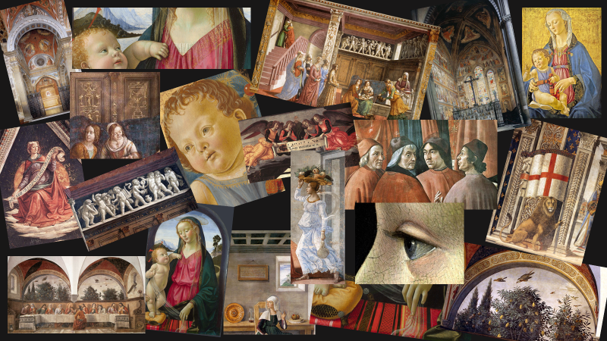

Teaching with Domenico Ghirlandaio…
Student Activities

Inspired by… a Mother Holding a Child

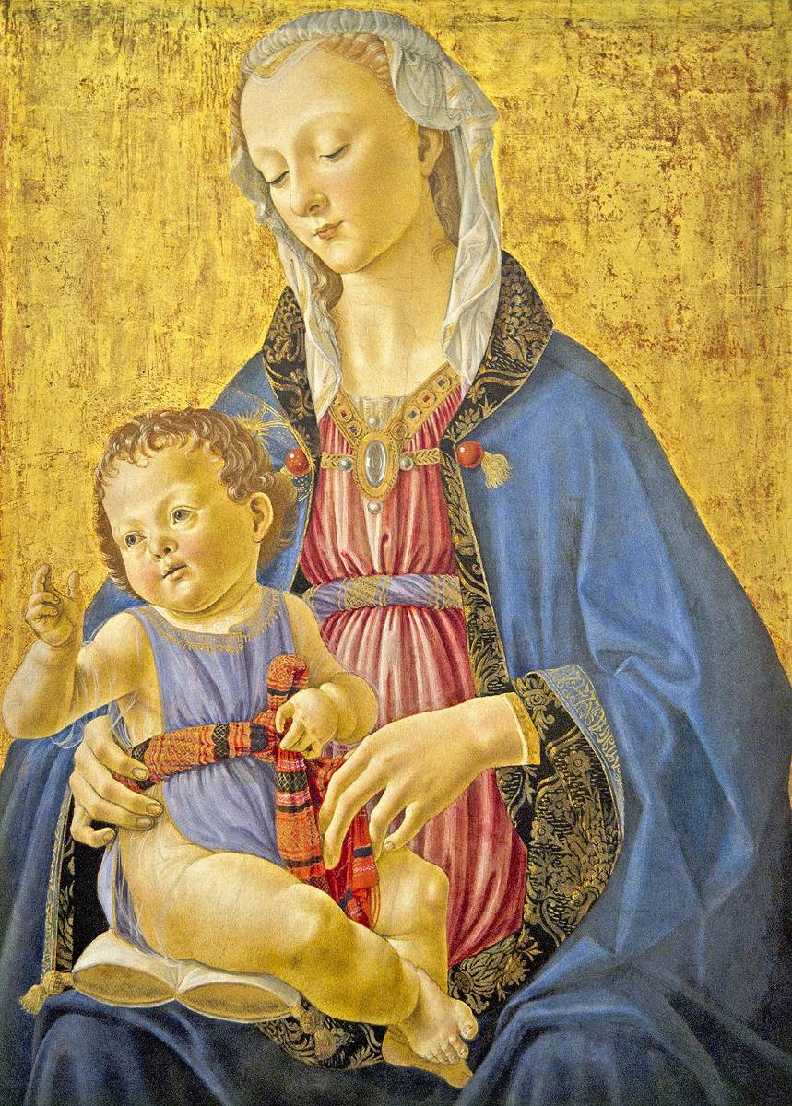
Domenico Ghirlandaio, 1449-1494
Madonna and Child (detail), 1470-75, Tempera on panel, 71 x 49 cm, National Gallery of Art, Washington, DC

The Madonna and Child by Domenico Ghirlandaio

This Activity is based on the Learning to Look method created by the Hood Museum of Art.
https://hoodmuseum.dartmouth.edu/learn/k-12-educators/educator-resources/learning-to-look/european-art
This discussion-based approach will introduce students to the five steps involved in exploring a work of art: careful OBSERVATION, ANALYSIS, RESEARCH, INTERPRETATION and CRITIQUE. Practice IN-CLASS the first steps and at the end, students are expected to write as a formative assessment the final CRITIQUE.
Critical Assessment and Response: It’s time to JUDGE how successful the work of art on focus is! This is an important part of the Learning Process and students are asked to answer the provided questions supporting their opinions based on their work done so far, “Critical assessment involves questions of value.” For example:

- Do you like this work of Art?
- How do you feel about this painting?
- Do you think Ghirlandaio’s painting Madonna and Child was successful and skillful in expressing the painter’s ideas?
- Is the painting still relevant to your life and your culture?

Writing about … a Grandfather

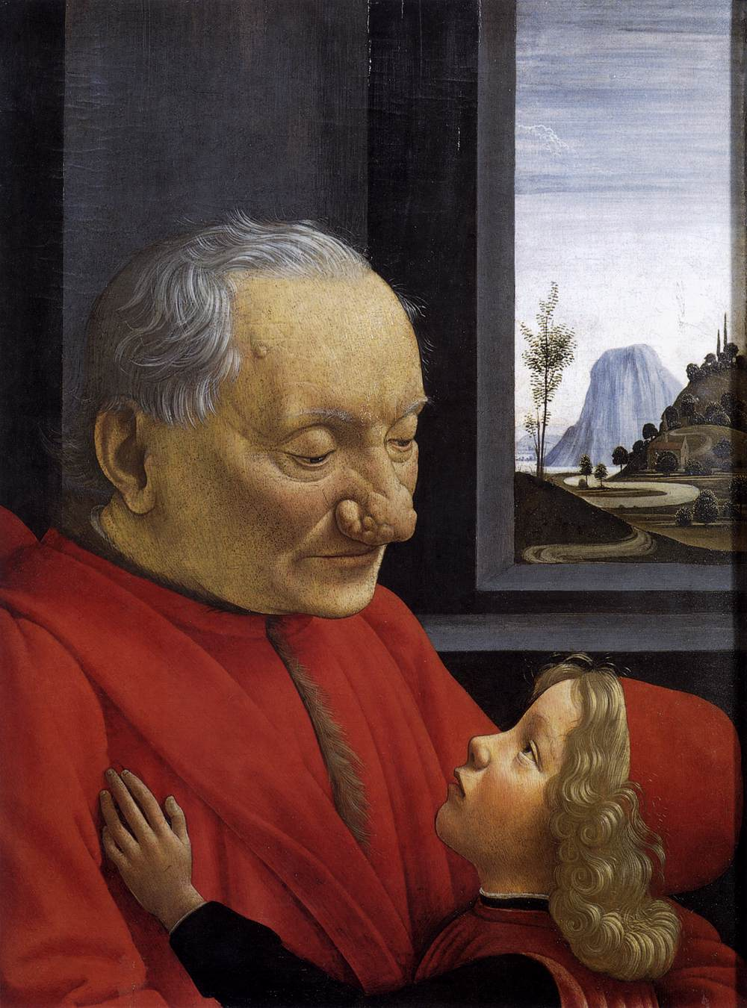

Domenico Ghirlandaio, 1449-1494
An Old Man and his Grandson, c. 1490, Tempera on wood, 62 x 46 cm, Musée du Louvre, Paris

Writing a story based on a painting
Inspired by: https://www.onestopenglish.com/download?ac=11056
Your Assignment is to describe Ghirlandaio’s painting with imaginary facts about the past and predictions about the future. This should be the basic structure of your story:

Introduction
Introduce the Painting, (correct identification is necessary- Nam of Artist, title, date, genre, current location) and briefly describe it.
First paragraph - Past
Who is the older man in the painting? What was he doing before the moment that is captured in the painting? Example – The older man in the picture was very busy checking business documents until…
Second paragraph - Present
What is the older man in the painting doing NOW? Example – He forgot everything because a child, his...
Third paragraph - Future
What happens next? Example – The old man is ready to celebrate the child’s…
Conclusion
There could be a surprising or funny end to the story. Make sure you use the correct tenses when talking about past, present and future.

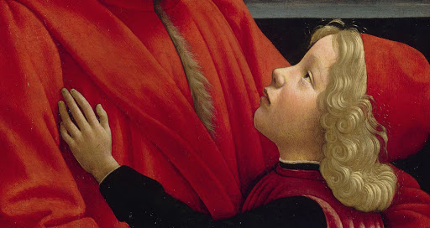
The Tornabuoni Chapel in the Church of Santa Maria Novella, 1486-90

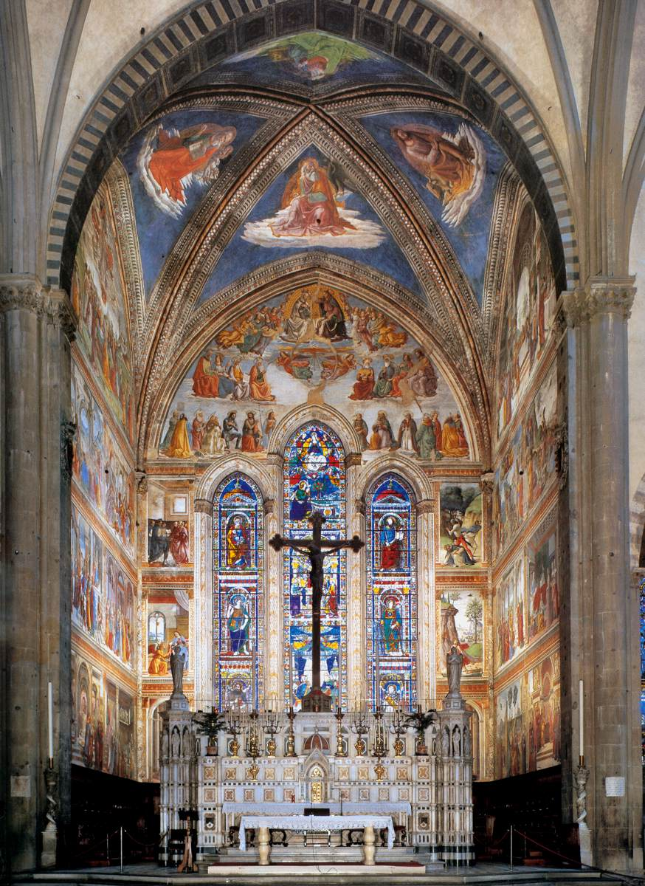

Explain to a friend, in writing, why visiting the Tornabuoni Chapel in the Church of Santa Maria Novella in Florence, is crucial to understand Tuscan Society during the 1480s.
For your assistance, please read: https://www.wga.hu/html_m/g/ghirland/domenico/6tornab/index.html
https://www.guidemeflorence.com/2020/04/24/tornabuoni-chapel/
LOOK… THINK… WRITE… You only have 2 Minutes!

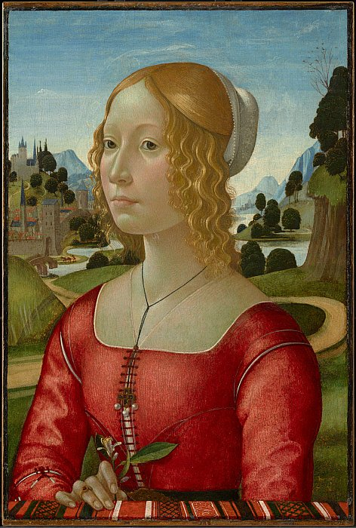
Portrait of a Lady, c. 1490, Tempera, oil, and gold on panel, 56.1 x 37.7 cm, The Clark Art Institute, Williamstown, MA, USA
Students have 1 minute to study the painting “Portrait of a Lady” in the Clark Art Institute and 1 more minute to brainstorm and write words related to the painting in focus…
http://clipart-library.com/free/scroll-clipart-transparent-background.html

