Interesting Lives…
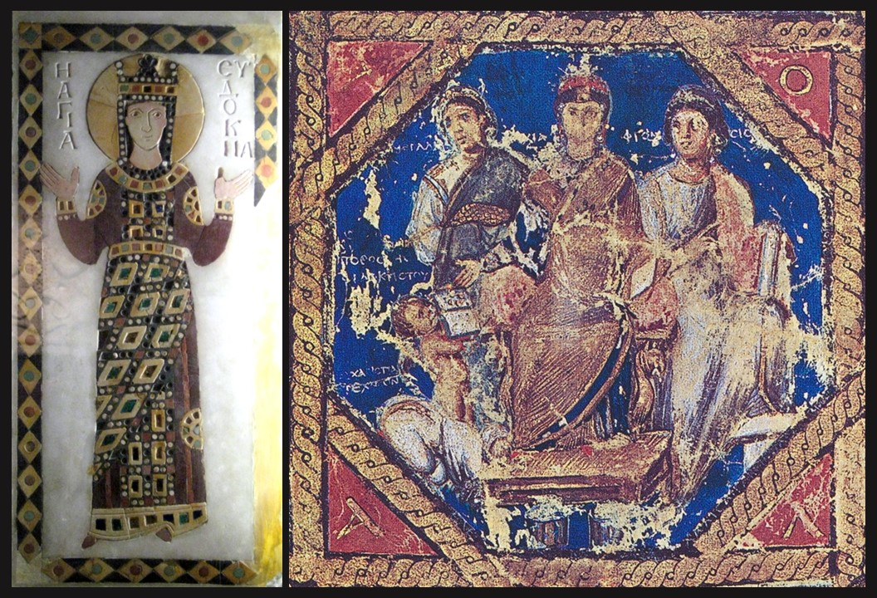
Empress Aelia Eudocia?, c. 907, coloured stone inlay on marble from Church of Lips Monastery, 66 by 28 cm, Archeological Museum, Istanbul http://monasticmatrix.osu.edu/figurae/icon-saint-eudokia
Portrait of Anicia Juliana flanked by Megalopsychia and Phronesis, Vienna Dioscurides, Folio 6v, about 515 AD, Byzantine Greek Illuminated Manuscript of De Materia Medica by Pedanius Dioscurides, vellum folios measure 37 by 30 cm, Österreichischen Nationalbibliothek, Vienna https://en.wikipedia.org/wiki/Anicia_Juliana#/media/File:Wiener_Dioskurides_6v_(portrait_detail).jpg
Empress Aelia Eudocia, and Anicia Juliana, great-granddaughter of Eudocia, are both, according to a Byzantine poem, responsible for the construction of a magnificent Church in Constantinople dedicated to the Holy Martyr Polyeuktos
Your assignment is to chose one of the two women, Empress Aelia Eudocia or Anicia Juliana, and write the story of an interesting incident in their life! Be prepared to share your story with the class!
Do not hesitate to ask your teacher’s help if needed!!!

