A Poem for Donatello’s Saint George

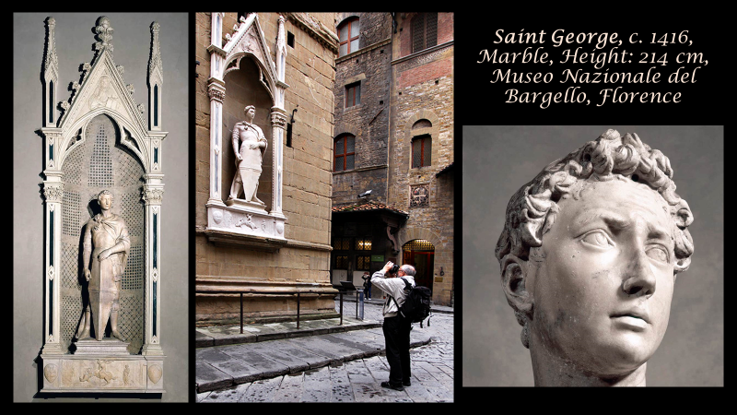

“Donatello was commissioned to sculpt St. George by the armourers guild of Florence. This piece was obviously meant to portray a youthful, courageous St. George, and few will dispute that Donatello's creation was anything but excellent.
St. George is widely regarded as a tribute to the classical heroes of antiquity. His features are strong and masculine, yet delicate and youthful, as Florentines of the period liked to imagine the fabled heroes of the past. Allegedly, Donatello sculpted St. George as he was thought to have been just moments before encountering and slaying the dragon. He appears deep in thought; his expression is slightly hesitant, yet determined and fearless.
Vasari wrote of St. George, "Life itself seems to be stirring vigorously within the stone. And to be sure no modern statues have the vivacity and spirit produced by nature and art, through the hand of Donatello in this marble."
https://www.artble.com/artists/donatello/sculpture/st_george

Write a poem about the brave Saint George… starting each line using the letters of the word George

G ……………………………………………………………………………………

E ……………………………………………………………………………………

O ……………………………………………………………………………………

R …………………………………………..……………………………………….

G ……………………………………………………………………………………

E ……………………………………………………………………………………

