Marcus Aurelius vs Gattamelata
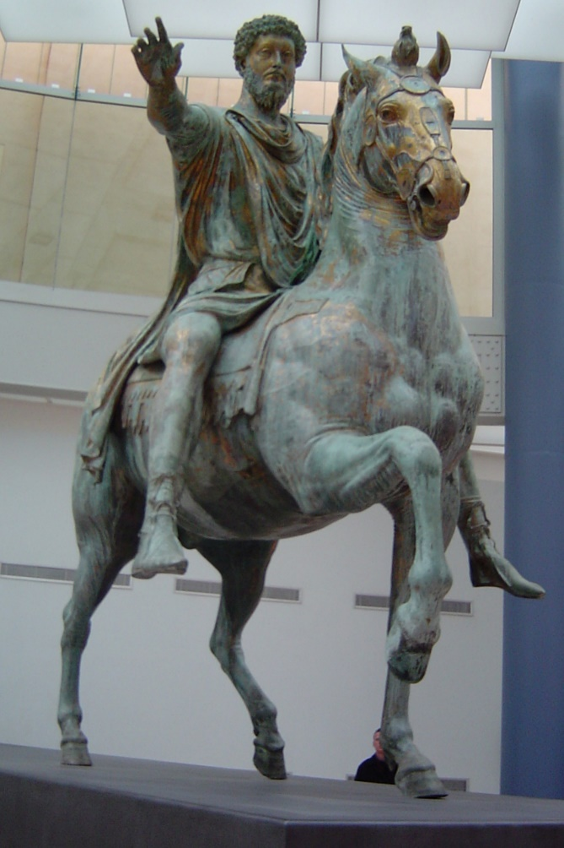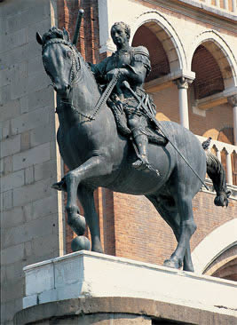
Equestrian Statue of Marcus Aurelius, c. 173-76, Gilded Bronze, Height: 4.2 m, Capitolin Museum, Rome
Donatello, 1386-1466,
Statue of Gattamelata, 1447-50, Bronze, 340x390 cm, Piazza del Santo, Padua
https://smarthistory.org/equestrian-sculpture-of-marcus-aurelius/
http://tom-historiadelarte.blogspot.com/2011/01/la-parte-por-el-todo-18.html

- Display on the screen the Equestrian Statues under focus. Explain that one of the Equestrian statues was done during the Roman period and the other was created by Donatello. DO NOT identify the statues to the students.
- Students are provided with the Activity Worksheet A. Ask students to do the Activity

