Dioscurides and Krithamo
We prepare a Poster
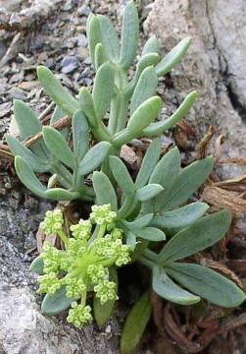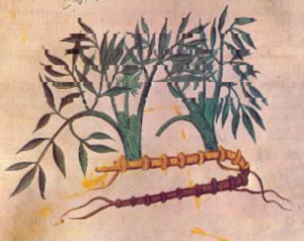
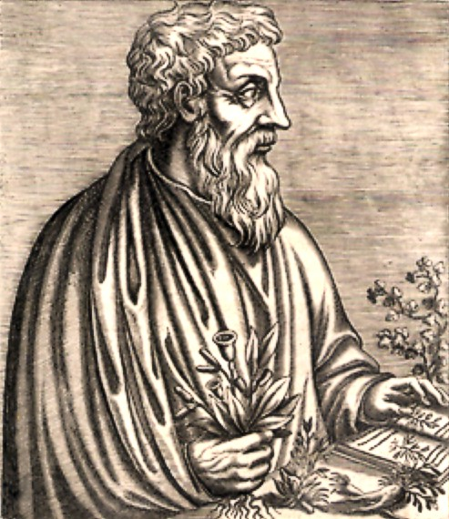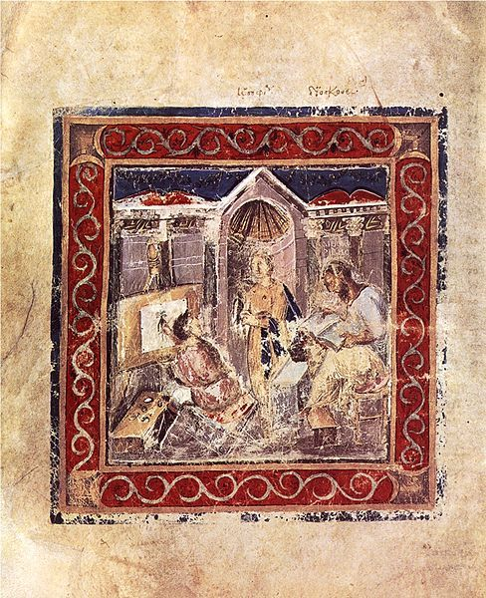
Students are asked to prepare a Poster with the following information and characteristics:
- Paper Size: A3 or A4
- Visuals: Photos of Krithamo, Dioscurides and the Miniature representing Krithamo from the Vienna Dioscurides
- Students are asked to answer the following questions:
- Who was Dioscurides and what did he do? b. What are the medicinal characteristic of Krithamo?
- Art: Be creative, get inspired by Krithamo and decorate your Poster

