The Torre Aquila Month of November
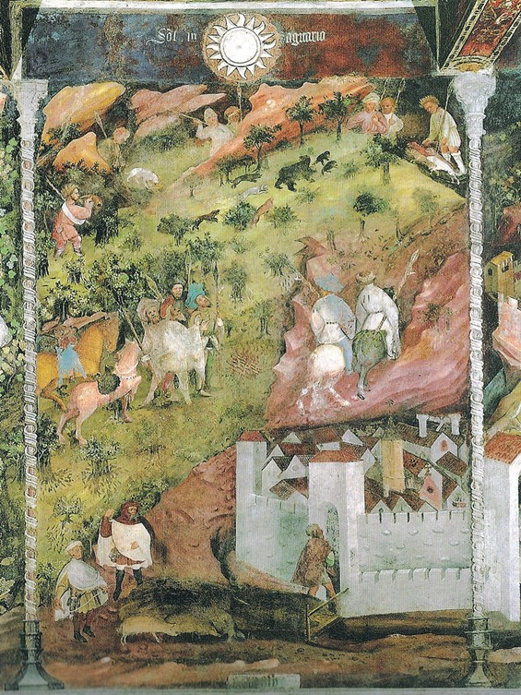
The Month of November, late 14thcentury-latest 1407, possibly by Maestro Venceslao, fresco, Torre Aquila, Castello del Buonconsiglio in Trento, Italy
Observation/Discussion Activity
- Project on the screen: The discussed Trento Month of November Fresco Panel. Students are asked to silently study the panel for a few minutes and to take notes of their observations. Continue with a discussion based on student observations and questions. Discuss with students how the artist of this panel organized his composition and how he used the Elements of Art.
- Students are asked to use their laptops and sign in to: http://www.vam.ac.uk/content/articles/m/med-ren-hunting/ a short article on Medieval & Renaissance Hunting by the Victoria and Albert Museum. Students are aske to read the article and listen to the Audios.

Research Activity
Students are asked to search the Internet and create a PowerPoint of at least 5 artworks depicting the theme “Medieval & Renaissance Hunting!”
How to research for paintings on the assigned theme: Go to Google - Medieval & Renaissance Hunting – Pictures.
Each painting should be correctly identified. (Correct identification should include: Name of artist, the title of the painting, date, medium , where the artwork is. For example: Titian, Bacchus and Ariadne, 1522-23, oil on canvas, the National Gallery, London)
Students are asked to write 2 sentences at least, explaining the reasons why they chose the particular Hunting Scene artwork.
Students are asked to BE CREATIVE! and prepare an appealing PowerPoint!!!

