Student Friendly – Questions

1st Slide: Funerary relief sculpture of a teacher with three “discipuli”, Gallo-Roman relief sculpture, 180–185 AD, sandstone, Rheinisches Landesmuseum, Trier, Germany

- How many people do you see in the picture?
- What do you think they are doing?
- Who is the Teacher? Explain why
- Circle one of the five adjectives to best describe the standing student: a. tardy, b. nervous, c. upset, d. troubled, e. happy

2nd Slide: School Scene A: lessons of music and reading between 3 bearded teachers and two young students, while representations of a basket, a pipes case, barbitons (musical stringed instruments) and cups hang above, Red Figure drinking Cup (Kylix), from Cerveteri, 480 BC, by the Douris painter, Antikensammlung, Staatliche Museum, Berlin, Germany

- How many Teachers and how many Students do you see in this picture?
- What do the students learn?

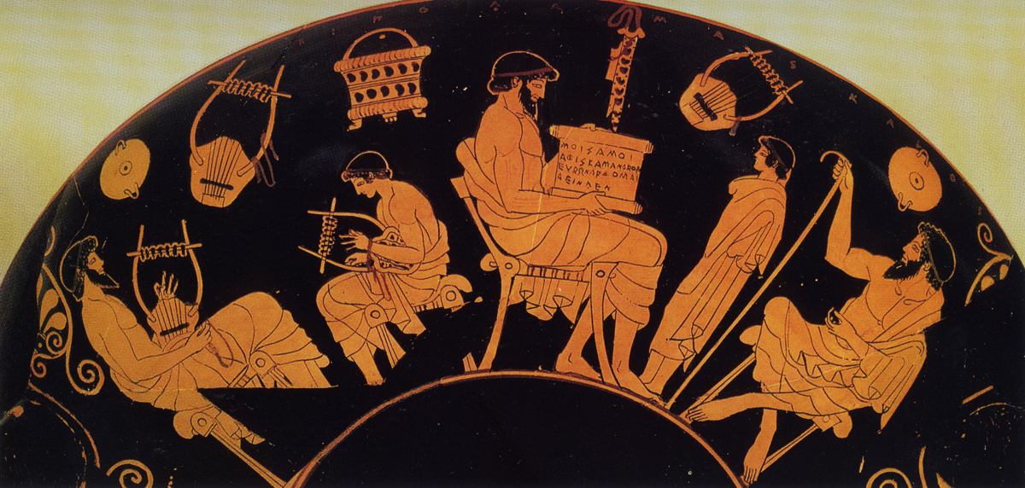

3rd Slide: School Scene B: lessons of music and writing between a Teacher, 2 older Students and 2 younger students, while representations of a pipes case, a barbiton (musical stringed instrument) and a writing case hang above, Red Figure drinking Cup (Kylix), from Cerveteri, 480 BC, by the Douris painter, Antikensammlung, Staatliche Museum, Berlin, Germany

- There are 4 people depicted on School Scene B. How do you recognize the oldest and the youngest? How do you recognize the age difference?
- Do you see a decorative motif that looks like a flower?

4th Slide: Kylix with two School Girls, Attic red-figure, attributed to the Painter of Bologna 417, ca. 460 BC, The MET

- Are the two figures depicted on the pot, boys or girls? How do you know?
- How do you know they are students?
- Use one of the five adjectives to describe the standing student: a. reluctant, b. nervous, c. upset, d. enthusiastic, e. happy

5th Slide: Grave Naiskos of an Enthroned Woman with an Attendant, 100 BC, Marble, 94.6 × 120.7 × 21.6 cm, the Getty Museum

- What is the attendant to the Enthroned Woman carrying? a. shallow box, b. computer, c. writing tablet, d. basket

6th Slide: Plato’s Academy, Roman mosaic of the 1st century BC, originally from Pompeii, now at the Museo Nazionale Archeologico, Naples, Italy

- Is the depicted Lesson in Plato’s Academy taking place indoors or outdoors?
- Where would you rather do lessons, indoors or outdoors?
- Look carefully at the picture. What do you like most?

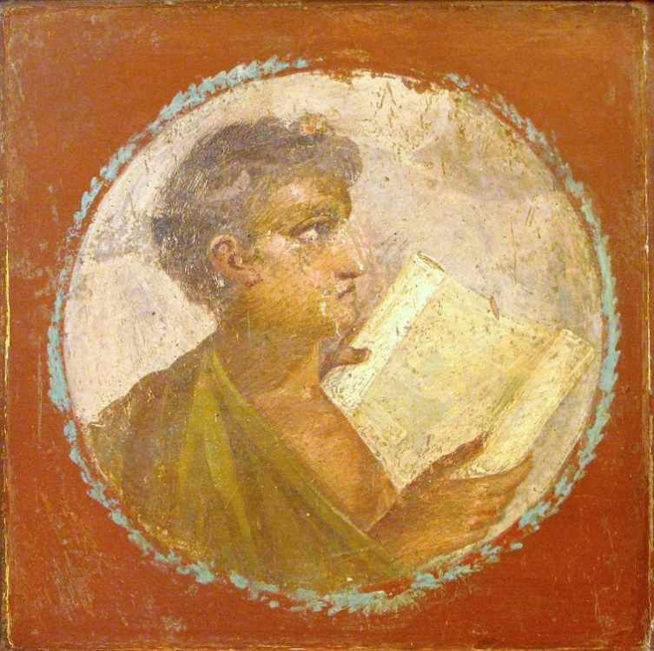
Roman portrait of a young man with a papyrus scroll, 1st century AD, from Herculaneum, National Archaeological Museum, Naples, Italy

For the Teacher – Questions, Answers and selected Bibliography

Instructions: As you show the “curatorteacher” prepared PowerPoint, ask the questions, explain facts and instigate a conversation.

https://www.adelphipaperhangings.com/products/anthemion-frieze-with-arthur-and-robert-stripe/

1st Slide: Funerary relief sculpture of a teacher with three “discipuli”, Gallo-Roman relief sculpture, 180–185 AD, sandstone, Rheinisches Landesmuseum, Trier, Germany
- How many people do you see in the picture?
(I see 4 people, 3 younger boys and one older looking, bearded man)
- What do you think they are doing?
(This is an ancient Roman sculpture depicting a classroom. The seated boys hold scrolls and the younger boys comes to class holding a writing tablet)
https://sites.dartmouth.edu/ancientbooks/2016/05/24/the-historical-background-of-the-ancient-scroll/
on Scrolls
http://www.romeacrosseurope.com/?p=1814#sthash.0EDis9oP.dpbs
http://www.dianesavonaart.com/blog/2018/1/30/wax-tablets
on Writing Tablets
- Who is the Teacher? Explain why
(The teacher sits between the two seated young students. He is bearded, obviously older. His chair has an attached footstool. These are all signs of importance)
- Use one of the five adjectives to describe the standing student: a. tardy, b. nervous, c. upset, d. troubled, e. happy
(I would use tardy, and explain the importance of coming to school ON TIME)
https://commons.wikimedia.org/wiki/File:Funerary_relief_found_in_Neumagen_near_Trier,_a_teacher_with_three_discipuli,_around_180-185_AD,_Rheinisches_Landesmuseum_Trier,_Germany_(29656302165).jpg
Gallo-Roman Funerary Relief

2nd Slide: School Scene A: lessons of music and reading between 3 bearded teachers and two young students, while representations of a basket, a pipes case, barbitons (musical stringed instruments) and cups hang above, Red Figure drinking Cup (Kylix), from Cerveteri, 480 BC, by the Douris painter, Antikensammlung, Staatliche Museum, Berlin, Germany
- How many Teachers and how many Students do you see in this picture?
(I see 3 teachers and 2 students. Teachers are bearded, looking taller)
- What do the students learn?
(One of the students practices Music using a Barbiton and the other practices reading)
https://en.wikipedia.org/wiki/Barbiton
on Barbiton, the musical instrument
https://www.beazley.ox.ac.uk/tools/pottery/painters/keypieces/redfigure/douris.htm
on the Red Figure Kylix in question

3rd Slide: School Scene B: lessons of music and writing between a Teacher, 2 older Students and 2 younger students, while representations of a pipes case, a barbiton (musical stringed instrument) and a writing case hang above, Red Figure drinking Cup (Kylix), from Cerveteri, 480 BC, by the Douris painter, Antikensammlung, Staatliche Museum, Berlin, Germany
- There are 4 people depicted on School Scene B. How do you recognize the oldest and the youngest? How do you recognize the age difference?
(The oldest person is bearded. He is the teacher. The 2 younger figures are beardless, and sit on stools. The youngest figures are depicted standing up.)
- Do you see a decorative motif that looks like a flower?
(Yes, on either sides of the composition, there is a decorative motif that resembles the fan-shaped leaves of a palm tree. This is called Palmette or Anthemion from the Greek word for flower)
https://www.britannica.com/technology/anthemion
https://en.wikipedia.org/wiki/Palmette
on Anthemion or Palmette

4th Slide: Kylix with two School Girls, Attic red-figure, attributed to the Painter of Bologna 417, ca. 460 BC, The MET
- Are the two figures depicted on the pot, boys or girls? How do you know?
(They are girls, dressed accordingly)
https://www.ancient.eu/article/20/ancient-greek-clothing/
on ancient Greek clothing women
- How do you know they are students?
(One of them is holding a Writing Tablet)
- Use one of the five adjectives to describe the standing student: a. reluctant, b. nervous, c. upset, d. enthusiastic, e. happy
(I would use the word reluctant)
https://www.metmuseum.org/art/collection/search/247330
on the Terracotta Kylix with the two School girls

5th Slide: Grave Naiskos of an Enthroned Woman with an Attendant, 100 BC, Marble, 94.6 × 120.7 × 21.6 cm, the Getty Museum
- What is the attendant to the Enthroned Woman carrying? a. shallow box, b. computer, c. writing tablet, d. basket
(The answer according to the archaeologists is a. shallow box. It could easily pass as a writing tablet)
http://www.getty.edu/art/collection/objects/7009/unknown-maker-grave-naiskos-of-an-enthroned-woman-with-an-attendant-east-greek-about-100-bc/
on the Grave Naiskos at the Getty Museum

5th Slide: Plato’s Academy, Roman mosaic of the 1st century BC, originally from Pompeii, now at the Museo Nazionale Archeologico, Naples, Italy
- Is the depicted Lesson in Plato’s Academy taking place indoors or outdoors?
(It takes place outside - tree, sundial, architectural buildings - as the background decoration suggests)
- Where would you rather do lessons, indoors or outdoors?
(Discuss with students possible answers)
- Look carefully at the picture. What do you like most?
(Discuss with students possible answers)
http://www.electrummagazine.com/2011/11/platos-circle-in-the-mosaic-of-pompeii/
on Plato’s Academy mosaic in Pompeii

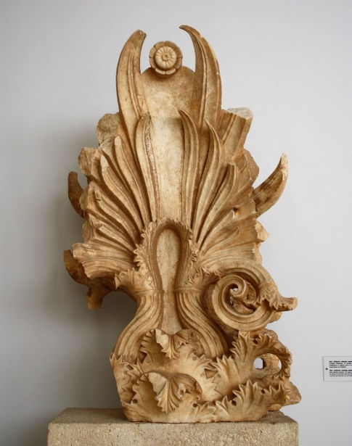
Fragment of an anthemion or palmette decoration, mid-4th century BC, the Archaeological Museum of Piraeus, Athens, Greece

