Writing Across the Curriculum - Verbs

Verbs are words that describe actions, conditions, feelings and experiences. There can be no sentence without a verb, in fact, a verb, RUN! can be a sentence by itself.

That said, when the English Language Department in my school introduced the WAC Program, I jumped in and started creating Verbs Activities, I hope you will find them useful.

The Detroit Institute of Arts Activity Visualizing Verbs is credited for this Activity.

https://www.dia.org/education/resources/visualizing-verbs

https://www.dia.org/sites/default/files/DIA_Verbs.pdf

Instructions
- Teacher EXPLAINS Activity expectations.
- Students’ GOAL is to find VERBS that best describes the composition in
Grant Wood’s The Midnight Ride of Paul Revere,
- Students are asked to WRITE sentences using their LIST OF VERBS to explain what is happening in the composition.
For more Visualizing Verbs Visual Art Activities, please take a look at: http://magazine.art21.org/2016/03/30/visualizing-verbs/#.XK4JqZgzZPY
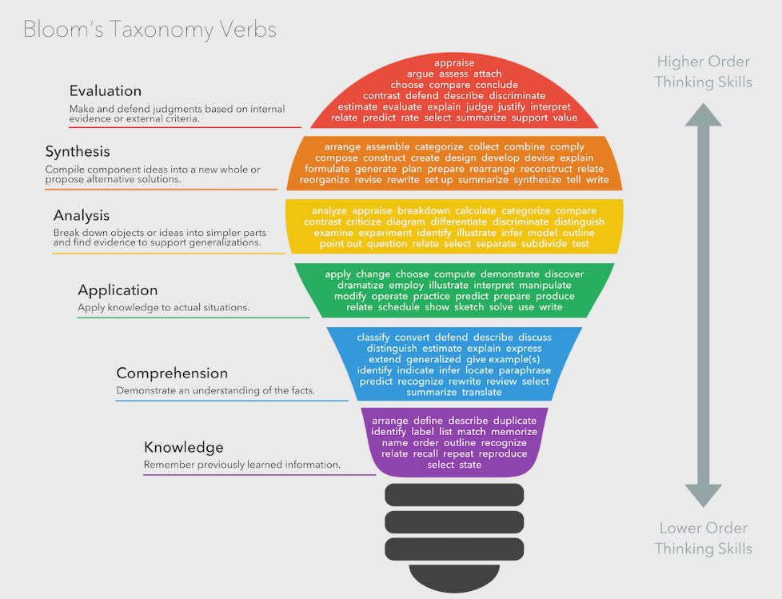
Bloom’s Taxonomy Verbs: https://commons.wikimedia.org/wiki/File:Bloom%E2%80%99s_Taxonomy_Verbs.png

