When Fashion becomes Art

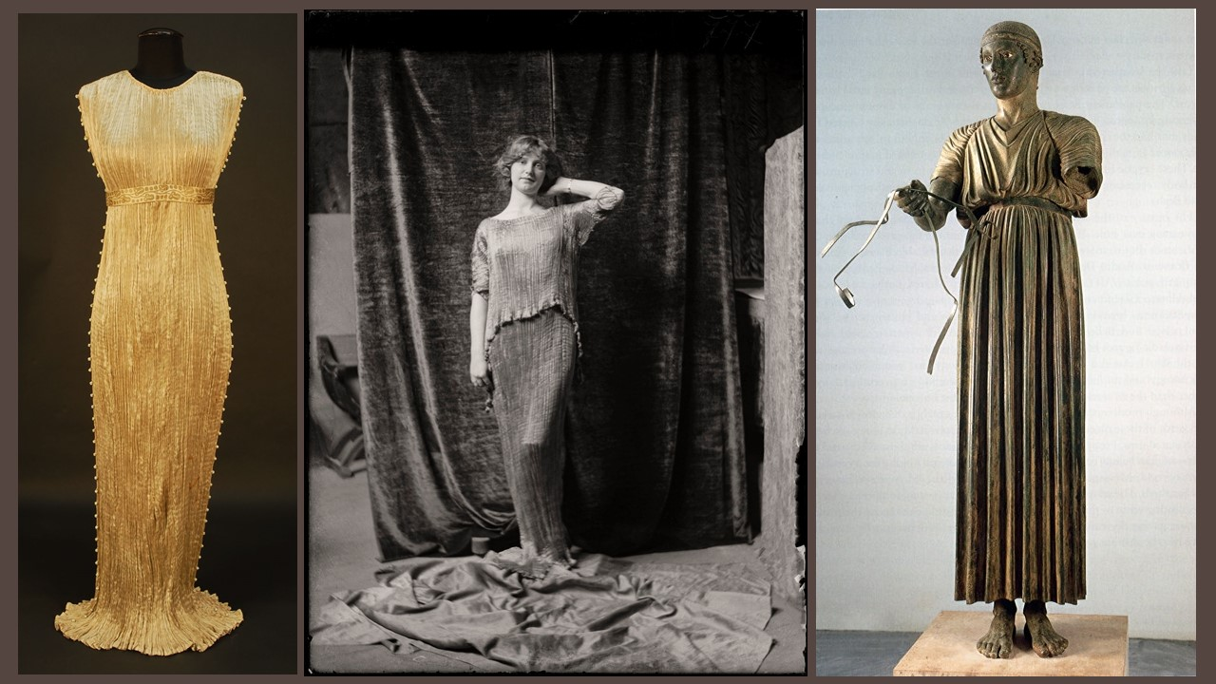

Mariano Fortuny y Madrazo, 1871-1949
Delphos Champagne pleated silk Dress with separate gold stenciled empire waistband, armholes and side seams decorated to hem with white, blue and yellow Murano glass beads, 1920, private collection
Delphos Dress, ca. 1920, Collezioni di Museo Fortuny, inv. MFN01711 ©Fondazione Musei Civici di Venezia, Museo Fortuny
The Charioteer, 478-474 BC, bronze, Delphi Archaeological Museum

Student Activity

Look at the picture and Find five adjectives that best describe Fortuny’s Delphos Dress

Think — What do you think has inspired the designer who created the Delphos Dress in the picture? List your ideas.

Look — Some fashion designers like to create harmonious designs with elements that complement each other. Do you see harmony in Fortuny’s Delphos Dress? Where? How?

Think and Write - Is the Delphos Dress loose-fitting or tight? How might you stand, walk or sit in it? Is the fabric heavy or light? Is the style formal or informal, complicated or simple?

