The Torre Aquila Month of July
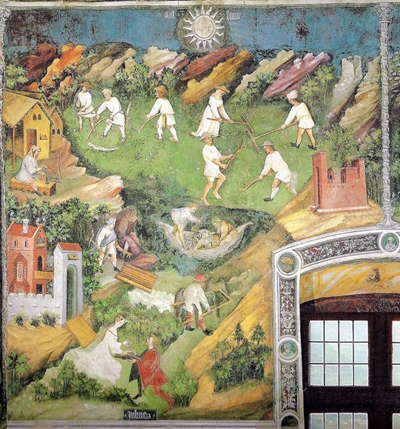
The Month of July, late 14thcentury-latest 1407, possibly by Maestro Venceslao, fresco, Torre Aquila, Castello del Buonconsiglio in Trento, Italy
Observation/Discussion Activity
Project on the screen: The discussed Trento Month of July Fresco Panel. Students are asked to silently study the panel for a few minutes and to take notes of their observations. Continue with a discussion based on student observations and questions. Discuss with students how the artist of this panel organized his composition and how he used the Elements of Art.

Research Activity
Students are asked to search the Internet and create a PowerPoint of at least 5 paintings depicting the theme “Summer Haymaking!”
How to research for paintings on the assigned theme: Go to Google - Summer Haymaking Paintings – Pictures.
Each painting should be correctly identified. (Correct identification should include: Name of artist, the title of the painting, date, medium , where the artwork is. For example: Titian, Bacchus and Ariadne, 1522-23, oil on canvas, the National Gallery, London)
Students are asked to BE CREATIVE! and prepare an appealing PowerPoint!!!

