Singer with a Glove…
“Art is not what you see, but what you make others see”
Edgar Degas

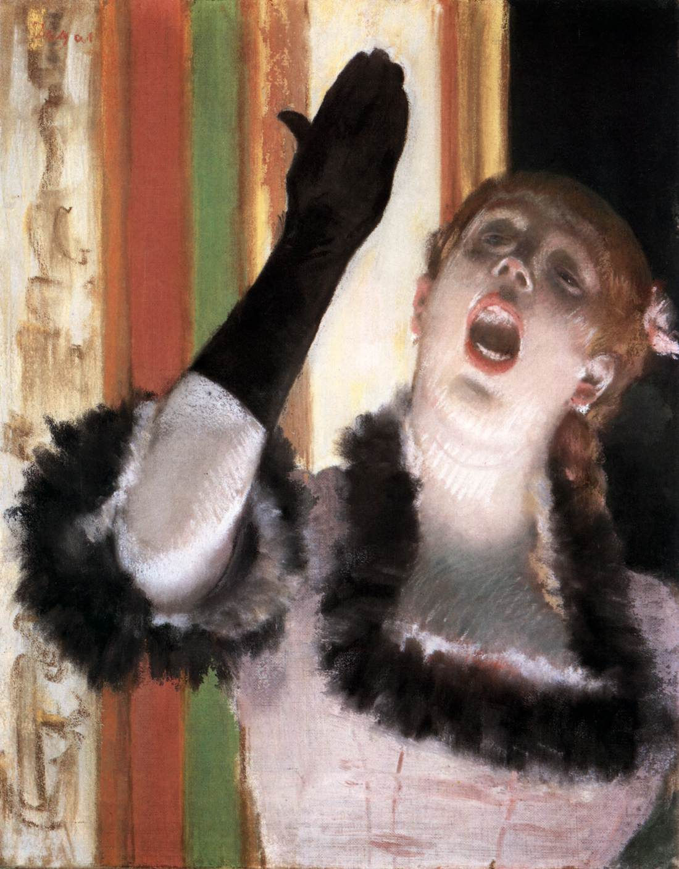
Edgar Degas, 1834 – 1917
Singer with a Glove, c. 1878, pastel on canvas, 53.2 x 41 cm, Harvard Art Museums/Fogg Museum

The Project should cover at least 2 pages of your RWAP Sketchbook.
RWAP stands for: Research – Writing – Art - Project

Instructions on what to do:
Your Project should include 4 parts:
- A Title
- Colored or Black/White copies of artworks related to your Project correctly identified
- The assigned Writing Assignment
- The Art Project

For more information on the painting go to: https://www.harvardartmuseums.org/art/228652
https://en.wikipedia.org/wiki/Singer_with_A_Glove
https://fashionhistory.fitnyc.edu/1884-degas-singer-in-green/

For more Degas paintings of Singers go to Google and search for Degas and paintings of singers. Use 2 of these painting for your RWAP requirements correctly Identified. (Artist, title date, medium, location)

Your Writing Assignment is to...
Consider the possibility that the Singer with a Glove is sending a Postcard to a friend of hers.
- What image would the Singer’s Postcard depict? Describe it!
- To whom would she send it?
- What message would she write?

Art Activity
This is only a suggestion:
Crate a collage of Degas Paintings of singers or a collage of photographs of your favourite singer… Create a portrait of YOU singing in any medium you like!... Create an A4 Postcard, decorate one side with the Art Activity and the other with the Writing Assignment…

General Instructions on what you should always do:
The Project should cover at least 2 pages of your RWAP Sketchbook
Your Project should include 4 parts:

Well thought and designed Title

Coloured or B/W copies of any artworks you use, correctly identified

The answers to the Assigned Writing Activity
- The Art Project

Be imaginative! Be creative! Be original!

