Comparing… two different styles!

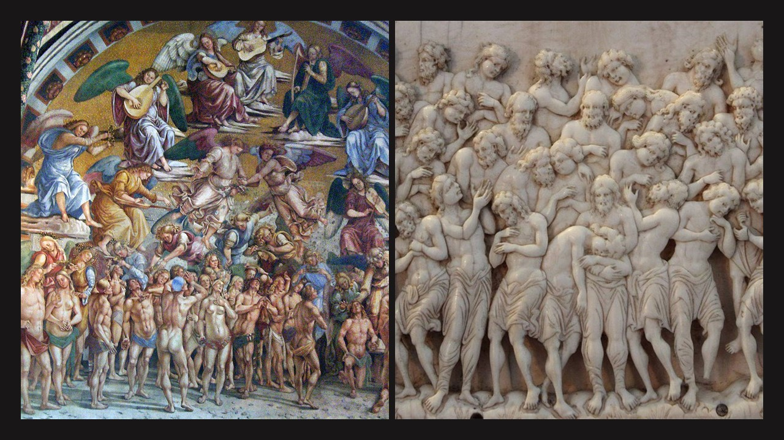
The Byzantine Forty Martyrs of Sebaste Ivory Icon of the 10th century in the BODE Museum
vs
Paradise by Luca Signorelli, a Renaissance 15th century fresco in Orvieto Cathedral
https://history2701.fandom.com/wiki/The_Forty_Martyrs_of_Sebaste
http://www.travelingintuscany.com/art/lucasignorelli/sanbriziochapel.htm

The Learning Objective is to Compare and Contrast a “similar” subject in two different historical Periods and Styles.
The 1st Activity Step is to examine the two artworks in focus: Forty Martyrs of Sebaste Ivory Icon and Paradise by Luca Signorelli. Students are asked to consider how the entire composition is organised first. Then move to groups within the composition, figures (body language) and finally emotions and facial expressions.
The 2nd Activity Step is for students to use the provided “Similarities and Differences” Worksheet and write down their observations.
The 3rd Activity Step is for students to share their writing with the rest of the class and compare their finds.
Similarities | Differences

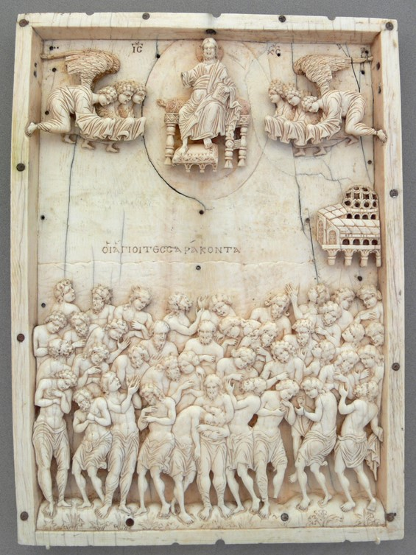

The Byzantine Forty Martyrs of Sebaste Ivory Icon of the 10th century in the BODE Museum
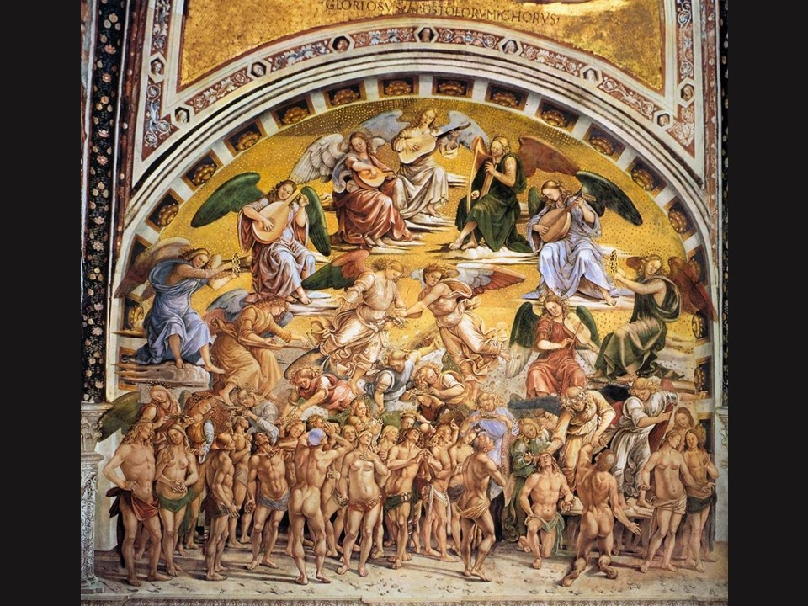

Paradise by Luca Signorelli, a Renaissance 15th century fresco in Orvieto Cathedral

