16th century Venetian Renaissance Art
Giovanni Bellini

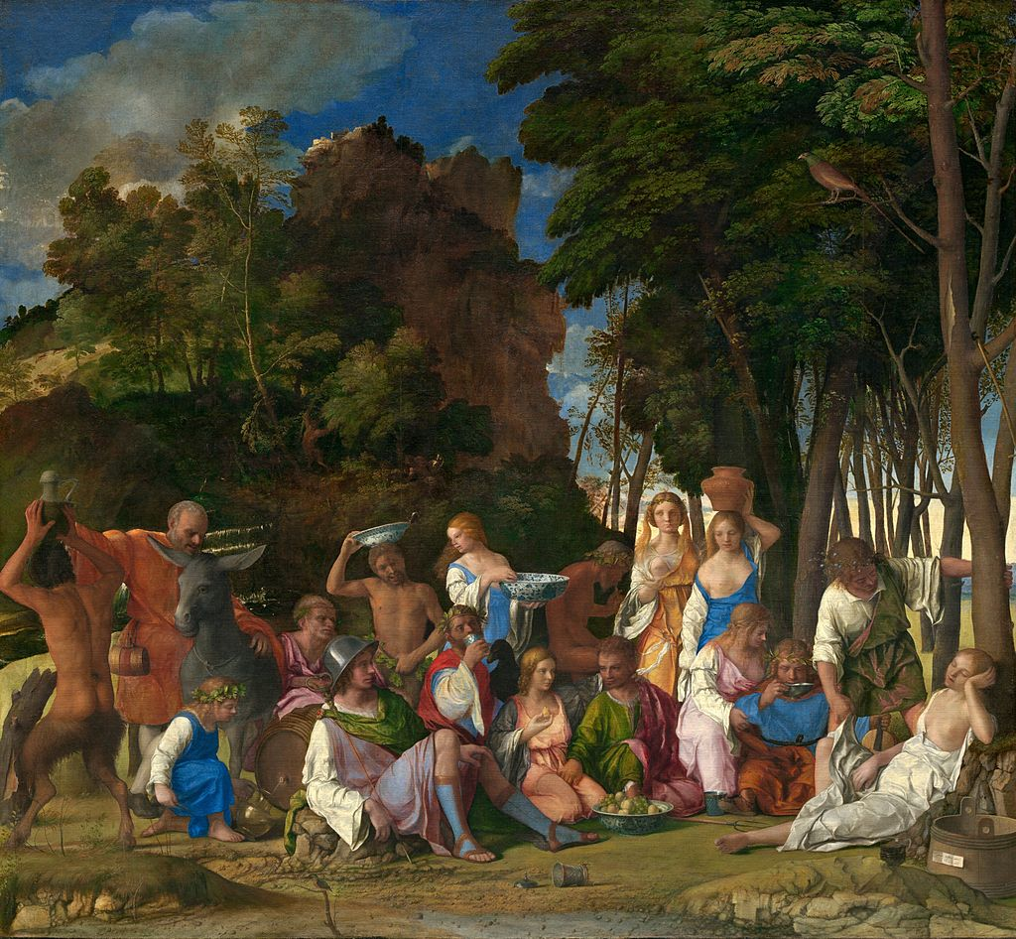
Giovanni Bellini, 1426-1516
The Feast of the Gods, 1514, Oil on canvas, 170 x 188 cm, National Gallery of Art, Washington
https://en.wikipedia.org/wiki/The_Feast_of_the_Gods#/media/File:Feastofthegods.jpg
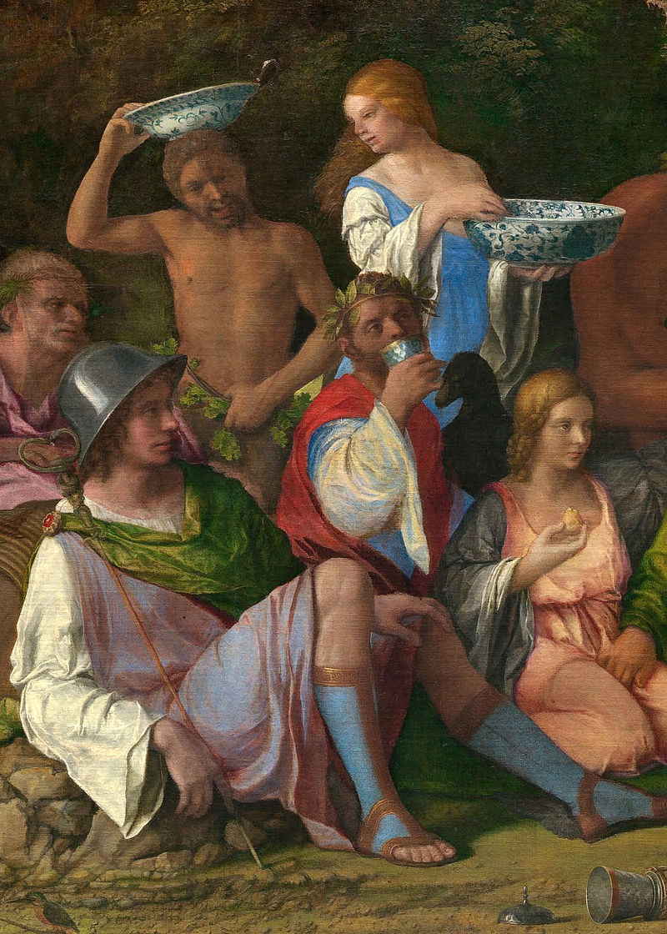
https://en.wikipedia.org/wiki/The_Feast_of_the_Gods#/media/File:Giovanni_Bellini_and_Titian_-_The_Feast_of_the_Gods_Detail-_Mercury_&_Chinese_porcelain.jpg
This detail of God Hermes and his companions shows the earliest known depiction of Chinese porcelain in European painting. Why do you think the Venetians were among the first to acquire and trade items of Chinese Porcelain?

……………………………………………………………………………

……………………………………………………………………………

……………………………………………………………………………

…………………………………………………………………………….

…………………………………………………………………………….

Why is the young man wearing a helmet identified as god Hermes?

……………………………………………………………………………

……………………………………………………………………………

……………………………………………………………………………

…………………………………………………………………………….

