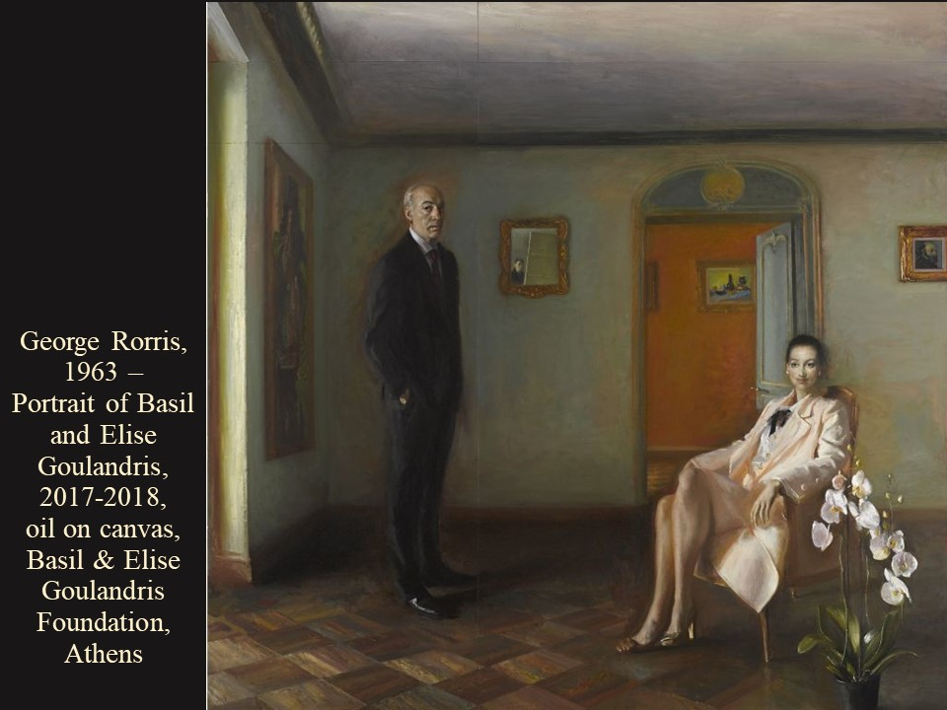
A “Bourgeois” Portrait under the Microscope

1st Activity
- Go to https://goulandris.gr/en/artwork/rorris-george-portrait-of-basil-and-elise-goulandris enlarge the picture if needed, and find the Mirror in the Portrait of Basil and Elise Goulandris.
- Describe what you see depicted in the painted Mirror.
- These kind of “Mirror” paintings are often referred to as “Reflection.” Read the following short article https://www.metmuseum.org/blogs/now-at-the-met/2014/reflections-charles-le-bruns-mirrored-presence and write your opinion on the George Rorris Basil and Elise Goulandris Portrait “Mirror Reflection.”

2nd Activity
- This is an Activity that tests your OBSERVATION! Be ART DETECTIVES!!!
- Go to https://goulandris.gr/en/artwork/rorris-george-portrait-of-basil-and-elise-goulandris enlarge the picture if needed, and find the 3 paintings depicted within the George Rorris Portrait Painting. The largest of the paintings is depicted on the left side, next to Basil Goulandris. On the top right side, another painting is depicted. Through the door on the back of the painting, Rorris painted the third of the paintings.
- Go to https://goulandris.gr/en/collection/works-of-art and try to identify which of the three paintings of the Basil and Elise Goulandris Collection are depicted in the George Rorris Portrait Painting. Write down your finds and present them to class.

