Adjectives starting with …

T  Terrific  Tremendous  Trendy  Tasty | I  Incredible  Imaginative  Illustrious  Important | F  Fine  Fantastic  Famous  Fashionable | A  Animated  Astonishing  Admired  Amazing

Instructions

Introductory Level
- Teacher EXPLAINS the meaning of each Adjective.
- Students’ GOAL is to find, for each Letter, the most descriptive Adjective for the word TIFFANY and what it represents.
- Students are asked to WRITE , the Adjectives of their choice, next to the corresponding Letter.

N  Nice  Nostalgic  Noteworthy  Noticeable | Y  Yearning  Yummy  Youthful  Yucky
TIFFANY

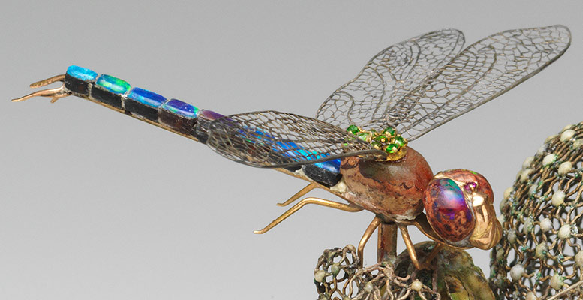

T.…………...…..……………
I..……………………………..
F......…………….……………
F.…………………...………...
A.…………………………….
N……………………………..
Y……………………………..

