The Tomb of Nebamun Activity
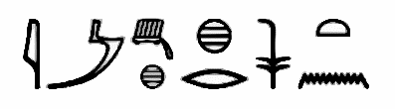

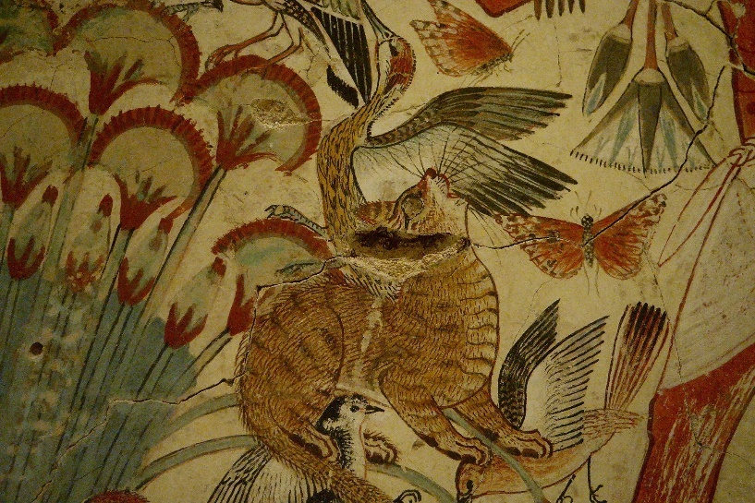

This is a BYOD (Bring Your Own Device) Activity
Instructions:
- Students have access to “Tomb of Nebamun” PowerPoint
- Students are asked to study the provided pictures, select 1 of them and then write a paragraph describing the picture’s composition.
- This paragraph should include
- an Introduction/Identification of picture
- a presentation of what can be seen in the picture of choice
- reference to the colors, lines, shapes and texture the artist used
- a sentence or two on the student reaction to the picture - how does student feel about the picture
- a sentence or two on why this painting is important – what students learn
- a closure to the paragraph
- Useful Tips: use descriptive adjectives and action verbs

Copyrights
https://commons.wikimedia.org/wiki/File:Ancient_Egyptian_official_title_jmAx_xr_nswt_(honored_before_the_king)_in_hieroglyphic.png
https://commons.wikimedia.org/wiki/Category:Tomb_of_Nebamun#/media/File:Cat,_Tomb_of_Nebamun.jpg

