Grade 6, Social Studies – Roman Unit RAP
Augustus of Primaporta vs Aulus Matellus

Project due:

The Project should cover at least 2 pages (centerfold) of your RAP Sketchbook or be an A3 size Poster

Instructions on what to do:
Your Project should include 4 parts:

Title

Colored copies of artworks related to your Project correctly identified. By correct identification, students are expected to write the name of the artist (if known), title of the work, date, medium, and current location.

Writing Assignment
- Art Assignment

Instructions on what to do:
Look/Read/Study the provided sites below and the pictures:
https://www.khanacademy.org/humanities/ancient-art-civilizations/etruscan/a/larringatore
https://www.khanacademy.org/humanities/ancient-art-civilizations/roman/early-empire/a/augustus-of-primaporta

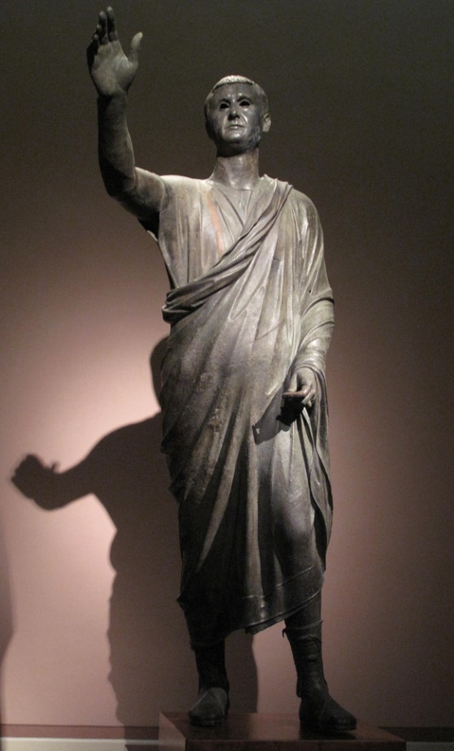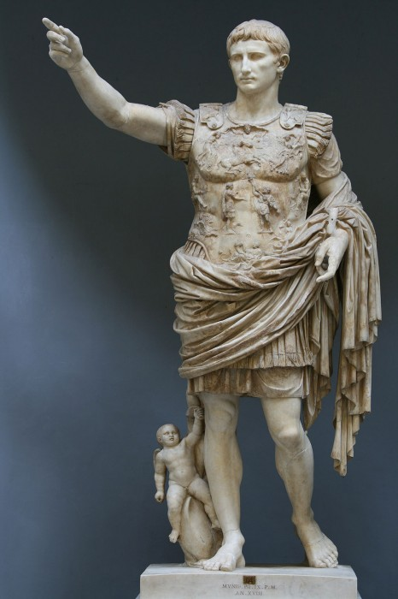

Aulus Metellus; also known as The Orator, in Italian, L'Arringatore, is a bronze sculpture 179 cm high. It is a Romano-Etruscan work from the late second century or early first century BC,
National Archaeological Museum, Florence
Augustus of Prima Porta is a 2.03m high marble statue of Augustus Caesar which was discovered on April 20, 1863, in the Villa of Livia at Prima Porta, near Rome, 1st cent. AD, white marble, Vatican Museums
Writing Assignment:

- Create a Ven Diagram comparing Matellus to Augustus. Use the RAP Book and write in Bullet Points your Comments.
- Write a paragraph presenting which of the two statues you prefer, explaining why by giving at least 3 reasons.

Art Assignment

“Study” the two statues and… Be imaginative! Be creative! Be original!

