Palm Tree Designs - How better can it get!

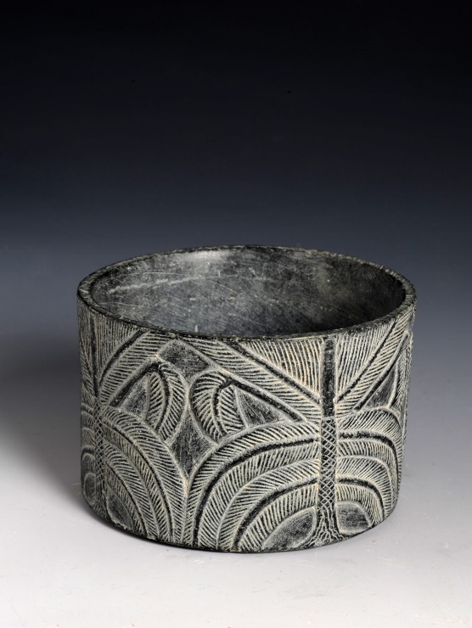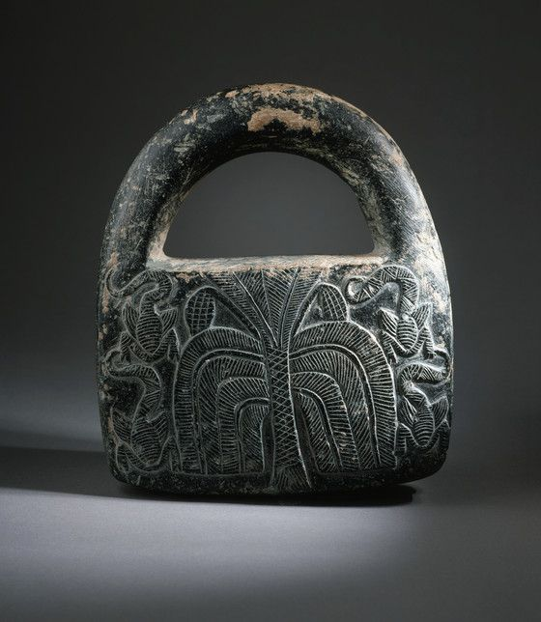

Cylindrical vessel with palm tree, approx. 2250–2000 BC, Saudi Arabia, Tarut island, al-Rufayah village, Chlorite, National Museum of Saudi Arabia, Riyadh
Chlorite handled weight. Northern Afghanistan. Bactria. Late 3rd - early 2nd century B.C. | Los Angeles County Museum of Arts Collections

Use the Worksheets I created. Photocopy them. I usually enlarge them, so as students have more space to work on.
Show students the prepared PP. Discuss how the Palm Tree is used as a decorative motif by the artists of the Bronze Age.
Show students how the designer Kendall Conrad got inspired by the LACMA chlorite handled weight. “This artwork first caught my eye because it was in the shape of a bag, but the carved image is what I fell in love with” she said.
https://observer.com/2017/06/wear-lacma-designer-collaboration-spring-2017/#slide1
https://www.thelacmastore.org/collections/fashion-wear-lacma/products/kendall-conrad-iphone-case

Ask students to be Imaginative, Creative and Artistic



