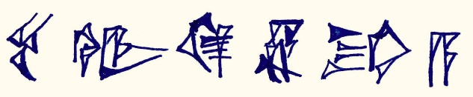
Epic Heroes
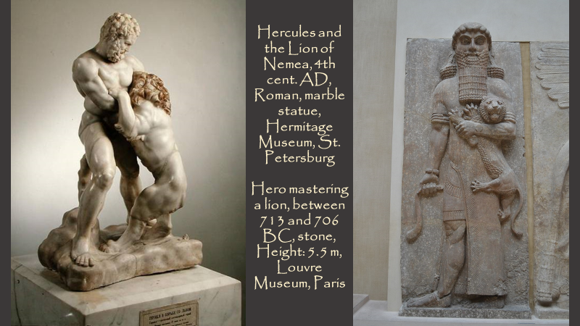

Students should be familiar with the Epic story of Gilgamesh, be able to identify Hero characteristics and pinpoint patterns in actions.

Students will be asked to brainstorm the names of other Mythological Heroes who have similar characteristics to Gilgamesh, behavioral attributes and a cycle of life.

Students will write the name of proposed Heroes on the classroom board and prepare for a group Activity. Depending on how many names of Heroes students offer, the classroom will be divided into groups. Each student group will work on a comparison between Gilgamesh and a second Hero, e.g. Hercules.

Students will be given Worksheets for two VENN Diagram “Compare and Contrast” Activities!

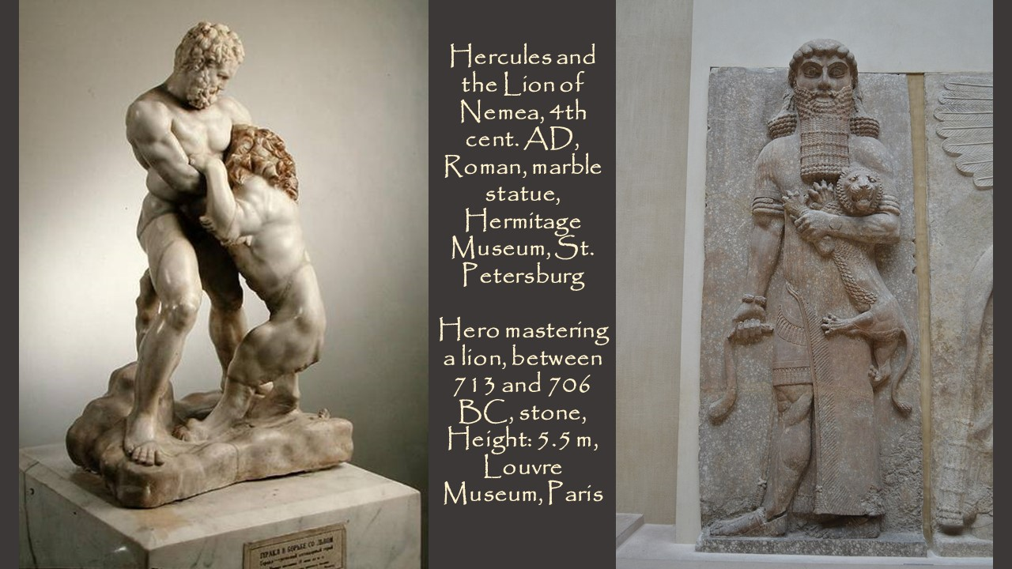
VENN Diagram A: Compare and Contrast Gilgamesh to the Mythological Hero …………………………………
VENN Diagram B: Compare and Contrast the 2 statues in the picture
