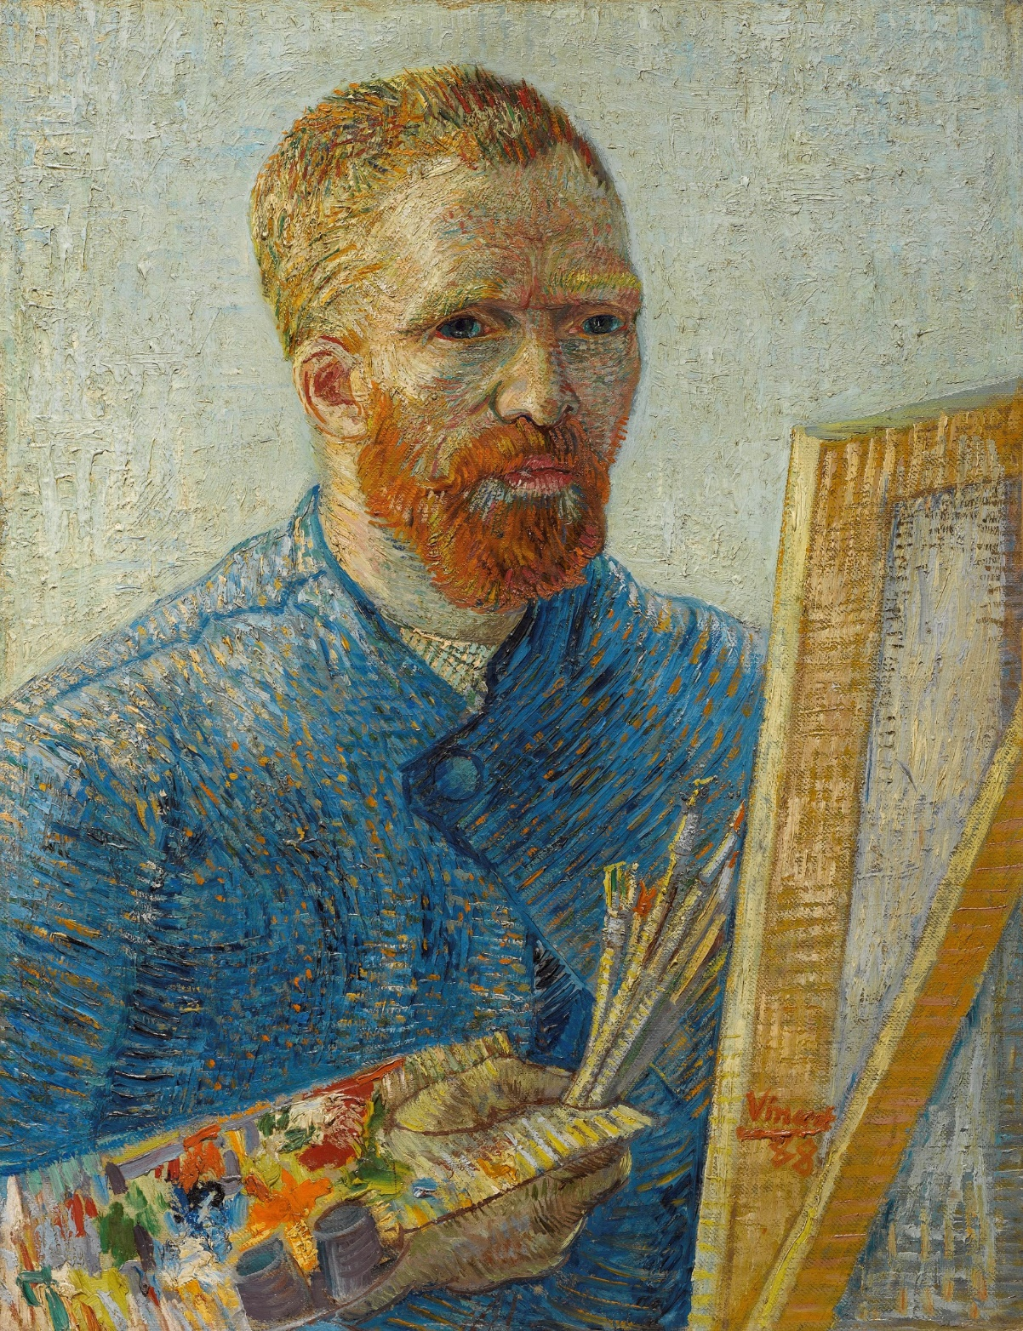
- Do you know who this person is?
Can you Guess?
Is it: Rembrandt van Rijn, Piet Mondrian, Vincent Van Gogh, Hans Brinker
- Look at the painting more closely.
Do you see at the painting any clues that tell us it was made by Vincent Van Gogh?

…………………………………

…………………………………..

- What painting material do you see?
What do you think he might be painting?

…………………………………

…………………………………..

- Circle the “best” adjective that describes Van Gog’s brushwork: soft, nervous, smooth, flat, flowing

- Identify the colours the artist used

…………………………………..

