From Rome to Byzantium: Depicting Faces

For Byzantine Art, the representation of the human face was important, yet very specific rules had to be followed, depicting it. Byzantine Portrait embody a spiritual presence and the eyes play the role of the protagonist! Eyes are affectionately called … the windows of the soul!

Project Instructions:
Carefully study the three Portraits and read the provided information.

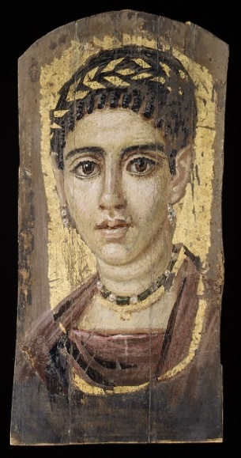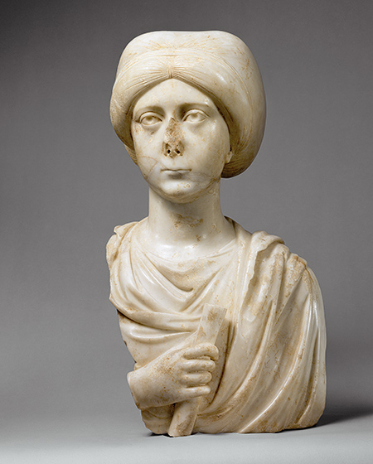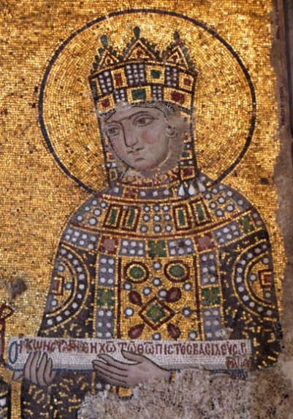

Portrait of a young Woman with Gilded Wreath, 2nd cent. AD, The MET, NY
Portrait Bust of a Woman with a Scroll, early 5th cent. AD, The MET
Empress Zoe, 11th cent. AD, from the mosaic of Konstantinos Monomachos and the Augusta Zoe in Hagia Sophia, Constantinople

Portrait of Roman with Gilded Wreath
This panel was not painted in the areas where the mummy wrappings would have covered the edges. Once in the wrappings, the background was gilded, and a gilded line was drawn to frame the lower end of the painting. Gold leaf was also used for the wreath and the lower necklace, a gold chain with a crescent (called a lunula). The woman's face and neck are thickly painted in cream, heightened with pink on the cheeks and nose and around the eyes. The shades are built up from a dark ground.
The woman's oval face, large eyes, and slightly open lips give the portrait considerable presence. Venus rings on her neck call attention to her youthful plump beauty. The hairstyle is typical for the period of the Emperor Hadrian, except for the corkscrew locks around the forehead, which may be a regional style.
http://www.metmuseum.org/collection/the-collection-online/search/547861

Portrait Bust of a Woman with a Scroll
This superbly carved portrait bust presents a pensive woman with a compelling gaze. She holds a scroll, the symbol of an educated person. The delicate, sensitive carving and the highly polished finish suggest that it was carved in Constantinople, capital of the Byzantine empire, perhaps as the funerary monument of a leading member of the imperial aristocracy. Her long fingers draw attention to the scroll in her hand, indicating her pride in being recognized as among the educated elite in an era that prized learning for both men and women.
http://www.metmuseum.org/toah/works-of-art/66.25

Empress Zoe
The figure of the Empress Zoe is depicted holding a scroll of parchment enumerating Imperial donations to the Great Church of Hagia Sophia in Constantinople. She has a plump face with a heavy nose, full brow and large yellow-gray eyes. Her rosebud painted mouth is small and her chin has a semi-circular cleft. Her hair seen below the crown is light brown. Her face has been made up like a doll, which reflects her famous and persistent pursuit of youth. Here in realistic portraiture is the doting, still popular old Empress without single wrinkle in her face in spite of her nearly 70 years.
The Empress wears a crown called a modiolos. On either side hang prependulia, which are composed of beryl and garnet stones, separated by pearls. The earrings of the Empress are a circle of pearls. She is dressed in full Byzantine court attire, clad in chiton, divitission, loros and shoulder piece. A part of the setting bed of the garments can still be seen and we can see the original fresco used by the mosaicist as a guide to setting the cubes. Above the head of the empress are three lines of inscriptions made in black-violet tesserae; they read - Zoe, the most pious Augusta.
http://www.pallasweb.com/deesis/constantine-zoe-hagia-sophia.html

Instructions on what is expected:
The Project should cover at least an A3 size Paper or 2 pages in an A4 size Sketchbook.
Your Project should include 4 parts:
- A nicely written title for your Project

Coloured copies of the three portraits, correctly identified

The answers to the Assigned Questions
- The Art Project

Questions that need Answers:
- Write 3 adjectives that best describe each Portrait
- Describe the way each artist positioned the face of the sitter and the eyes in particular.
- Which one of these portraits, is the most realistically depicted? Why? What do the three portraits have in common? What are the differences?
- Which one of these three women looks the most “modern” to you? Why?
- Do you think the different media used for these portraits account for the differences among them? How?
- Do you get a sense of the psychological state of any of these women? Which one? Why?

Art Activity:
Create another Triptych of three portraits, this time of Contemporary Women. Explain why you chose them and what they represent for you.

